Table of Contents

1.0 Introduction 3

2.0 Screen Designs 5

2.1 Login Interface 5

2.1.1 Home Form 5

2.1.2 Admin Login Form 7

2.1.3 Operator Login Form 9

2.2 Admin Interface 11

2.2.1 Admin Menu Form 11

2.2.2 Add Car Form 12

2.2.3 Add Operator Form 15

2.2.4 Edit Car Form 17

2.2.5 Edit Operator Form 19

2.2.6 Remove Car Form 22

2.2.7 Remove Operator Form 24

2.3 Operator Interface 27

2.3.1 Operator Menu Form 27

2.3.2 Add Customer Form 28

2.3.4 Edit Customer Form 30

2.3.5 Search to Assign Form 34

2.3.6 Assign A Car Form 36

3.0 Report Design 40

3.1 Car Report 40

3.2 Transaction Report 40

4.0 User Manual 42

4.1 Login 42

4.1.1 Home Form 42

4.1.2 Admin Login 42

4.1.3 Operator Login 43

4.2 Admin Interface 44

4.2.1 Admin Menu Form 44

4.2.2 Add Car Form 44

4.2.3 Edit Car Form 45

4.2.4 Remove Car Form 47

4.2.5 Add Operator 48

4.2.6 Edit Operator Form 49

4.2.7 Remove Operator Form 50

4.3 Operator Interface 51

4.3.1 Operator Menu Form 51

4.3.2 Add Customer Form 51

4.3.3 Edit Customer Form 53

4.3.4 Search to Assign Form 55

4.3.5 Assign a Car Form 56

4.3.6 Car Report Form 59

4.3.7 Transaction Report 59

# 1.0 Introduction

Task

Our task involves developing a new car rental management system for Ken Travel Agency who is venturing into the car rental business in order to improve their revenue and provide a one-stop integrated travel service for their customers. The system consists mainly of two types of users; admin and operator, in which they should have the capabilities of adding and editing information of customers, cars and even operators. However, the main feature that the system should have is to allow the operator to perform bookings for customers who are in need to rent a car for travelling purposes based on their requirements and needs of a type of car they would like to rent.

Scope

Based on the system that will be developed, it is currently capable of performing bookings for customers who would want to rent a car from the agent. The booking process allows customers to select one specific car model which is currently available and once selected, it would display the car details such as car ID, price and deposit. Once customers are satisfied with their choice, they would be able to select the day, date and time they would like to start renting the car and return the car, in which the total amount to be paid will be calculated and displayed depending on the car they rent and for how long they would rent it.

After the booking process, the operator is also capable of generating a transaction report based on the transaction information provided after bookings have been performed, for performance or sales comparison. Furthermore, users have the capabilities of adding and editing information, depending on their authority to access the type of information. For instance, operator is able to add new walk-in customers into the system for booking or edit customer information if there are any changes in their details. Compared to admin, who is able to add or remove car information and operator.

Limitations

Based on the system development, there is a limitation which is the limited authority for both types of users. For instance, even though the admin and operator are able to add and edit information from the system, they do not have the authority to the database where it contains all of the customer, car, operator and transaction information for security purposes, to prevent information from getting deleted or edited without any authorisation.

Objectives

* Achieve operational excellency
  + With the development of the system, we aim to achieve operational excellency by providing a more efficient and effective booking process which would lead to several benefits such as increasing productivity, reducing costs and improving quality of service.
* Improving customer service
  + The traditional booking method where customers would make a phone call or send an email to rent a car is rather time consuming and less effective. With the development of the new system, we aim to make the booking process more efficient in order to improve the quality of the service provided to customers in order to increase customer satisfaction, leading to long-term benefits.
* Reduce operational costs
  + With the new system, we are aiming to reduce costs by providing IT based solutions such as by reducing the time spent during booking process and minimizing labour by reducing the need to hire more staff since the system would automate most of the tasks and current staff could be retrain to use the system which would also increase staff productivity.
* Increase profitability
  + If we achieve operational excellency, we would be able to increase sales and profit considering the efficient process of the booking which would attract more customers to Ken Travel agency due to the improve in customer service and by being able to reduce expenses, it would be possible to increase profit.

# 2.0 Screen Designs

## 2.1 Login Interface

### 2.1.1 Home Form

Storyboard

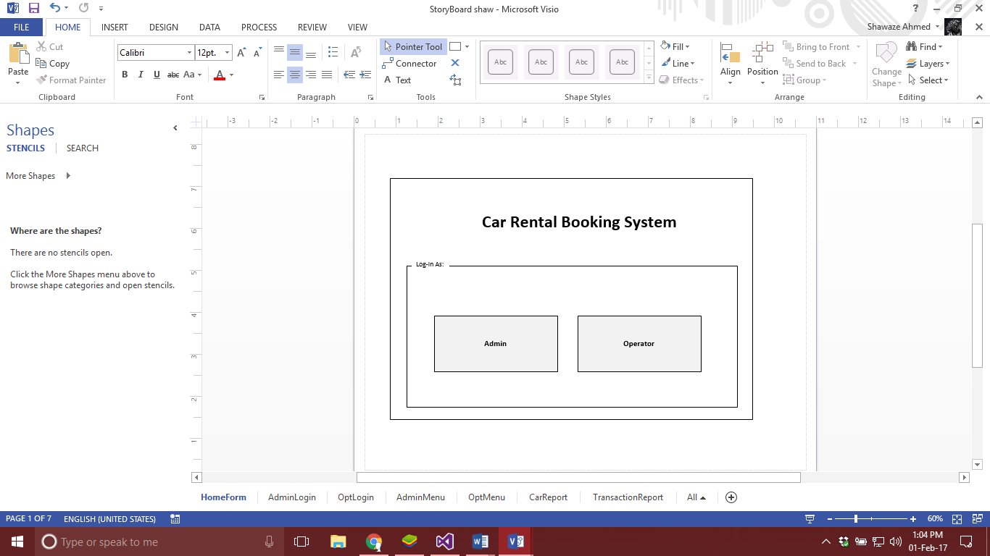

btnOpLog

btnAdminLog

Flowchart

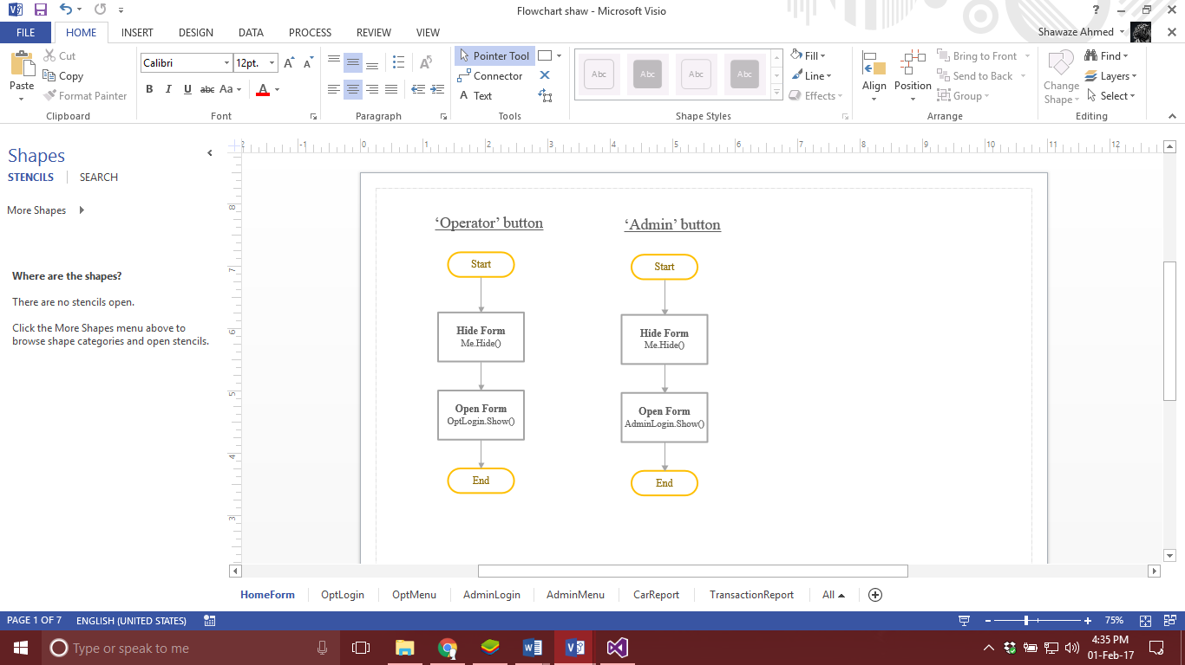

Explanation

This form is the first form an admin or an operator will get to see before they can log in into the system. This form allows the user to select which user would they like to log in as, since these buttons lead to different menus.

### 2.1.2 Admin Login Form

Storyboard

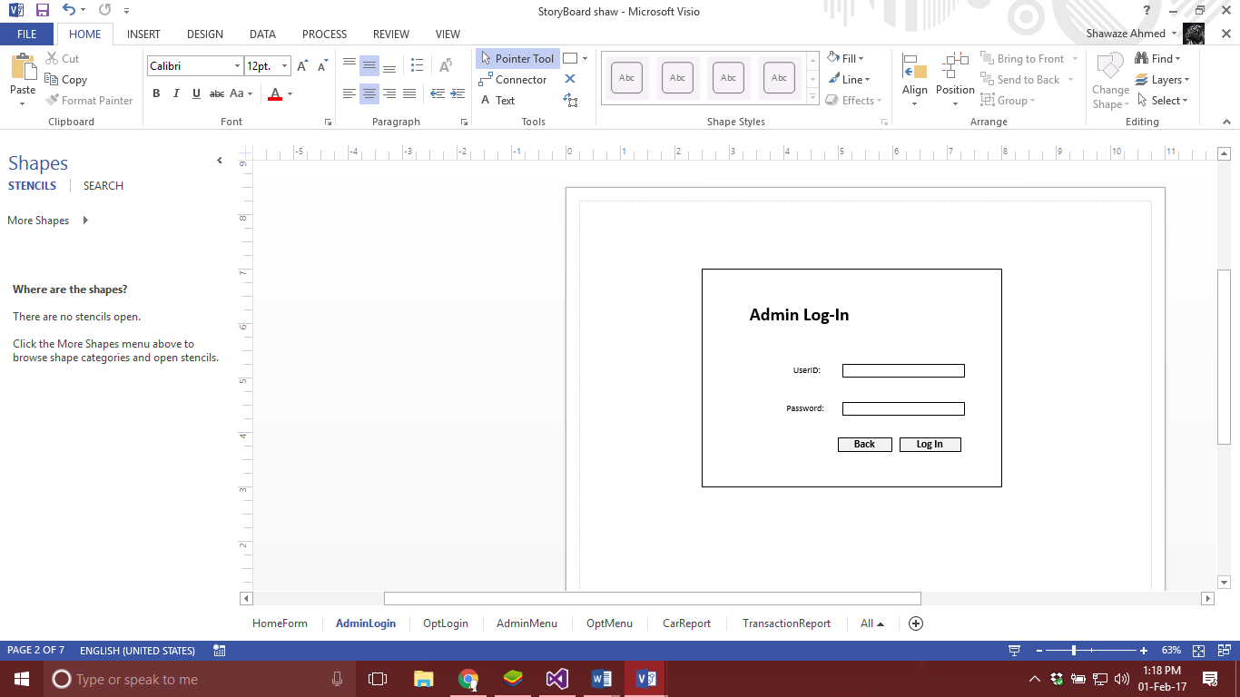

txtPass

txtUserID

btnLogin

btnBack

Flowchart



Explanation

This form is where admin is required to fill in the UserID and Password to make sure it is the right person logging into the system. There is ‘Log In’ button user can click once the textboxes are filled to log into the system, if the user details are found from database then admin is able to log in; however, if user is not found then a dialog box is shown. There is also ‘Back’ button user can click to return back to the previous form.

### 2.1.3 Operator Login Form

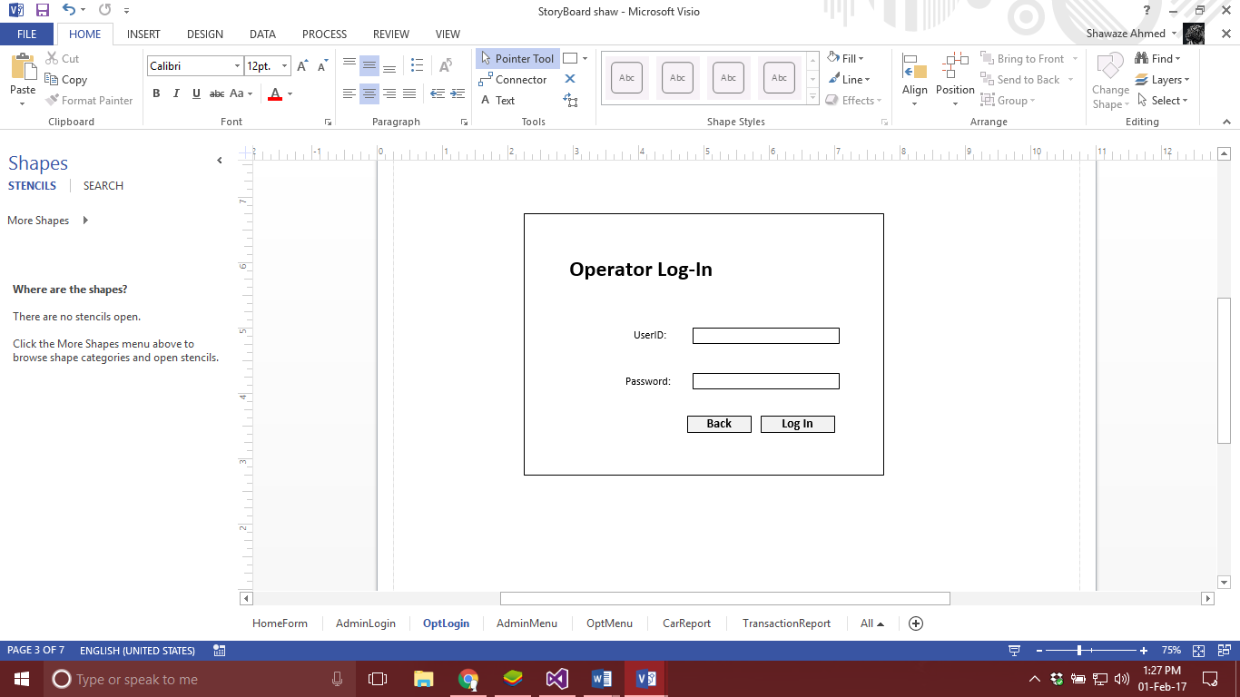

txtPass

txtUserID

btnLogin

btnBack

Flowchart



Explanation

This form is similar as admin log in form, it also provides textboxes where operator is required to fill in the details to be able to log in when the button ‘Log In’ is clicked or else the user can return ‘Back’ to the previous form by clicking the Back button.

## 2.2 Admin Interface

### 2.2.1 Admin Menu Form

Storyboard

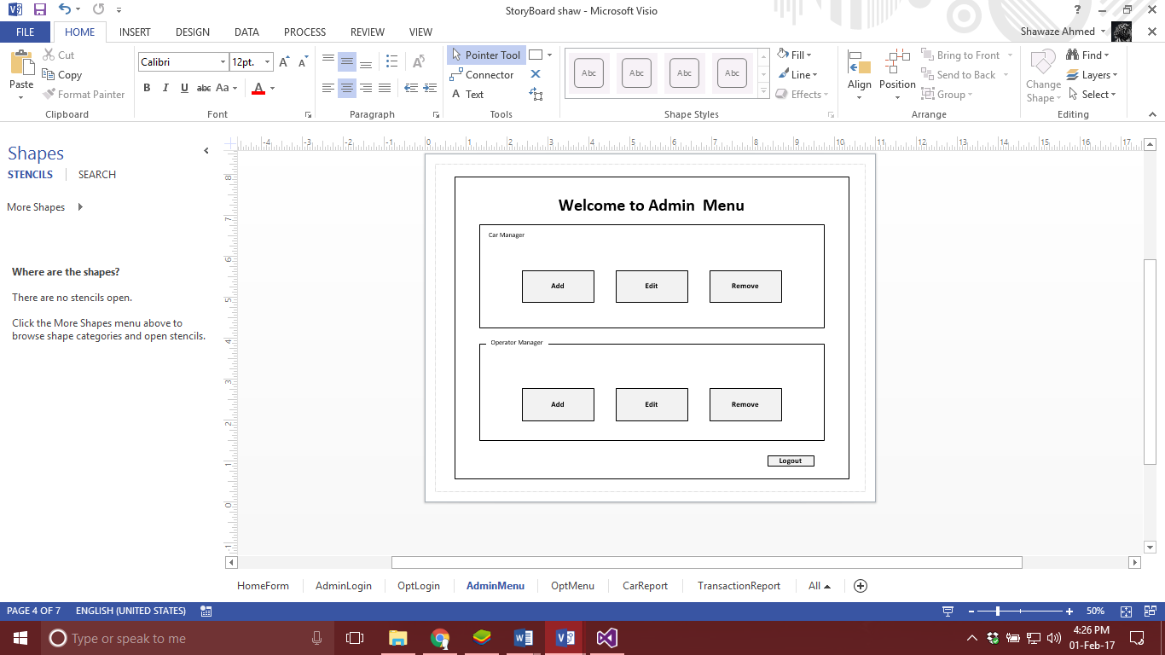

btnCarAdd

btnCarEdit

btnCarRemove

btnOpRemove

btnOpAdd

btnOpEdit

btnLogout

Flowchart

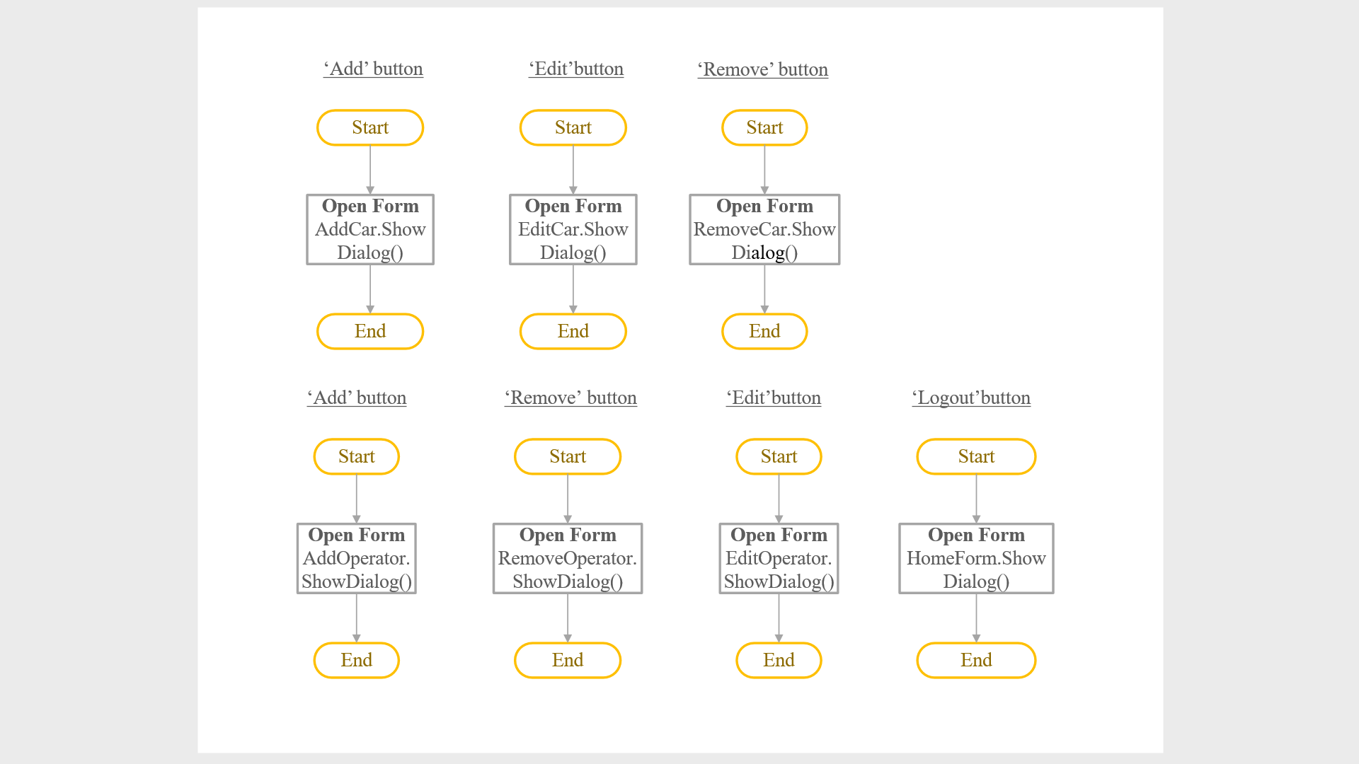



Explanation

The Admin Menu Form has buttons that are grouped into two boxes which are Car Manager and Operator Manager. Car Manager Group box contains button Add, Edit and Remove that lets admin add new cars, edit them or remove them. The admin is directed to another form when buttons are clicked. Operator Manager Group box contains two buttons Add and Remove which allow admin to add and remove operator if required; otherwise the admin can click on logout button to go back to the Home Form.

### 2.2.2 Add Car Form

Storyboard

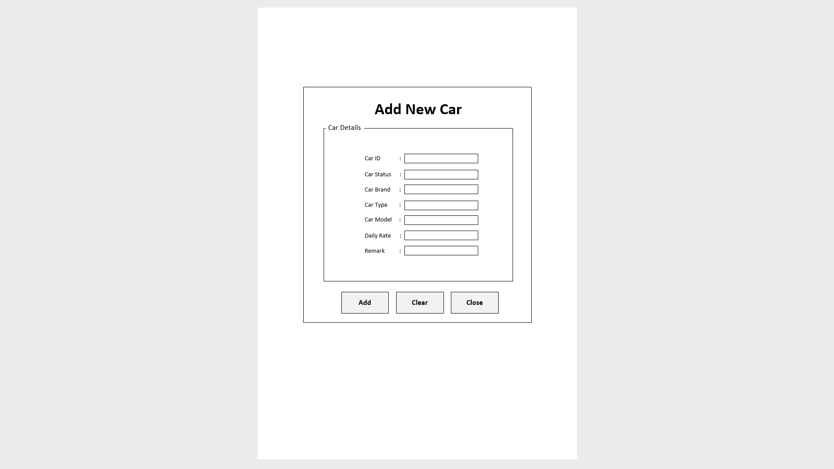

btnAdd

btnClear

btnClose

txtCarID

txtCarStatus

txtCarBrand

txtCarType

txtCarModel

txtDailyRate

txtRemarks

Flowchart

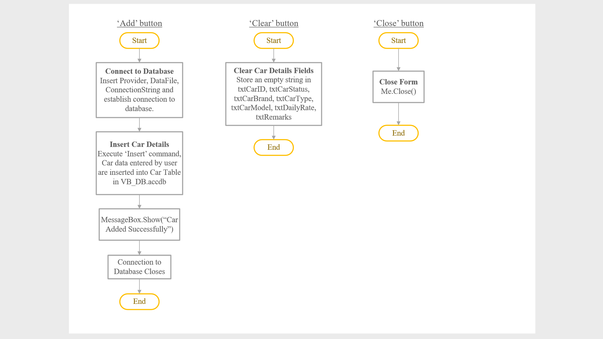

Explanation

This form is to be used by Admin to add new cars into the system. There are textboxes where admin can input the details of the car such as the Car ID (unique car plate number), Car Status (either Rented or Available), Car Brand, Car Type, Car Model. Daily Rate, and Remark (optional). These textboxes with their related labels are inside a group box to make it look neat. The ‘Add’ button will add all entered details into the corresponding fields in the car table in the database and display a message box saying “Car Added Successfully”. The ‘Clear’ button will clear all textboxes in the form. If there are no more changes, the form may be closed using the ‘Close’ button.

### 2.2.3 Add Operator Form

Storyboard

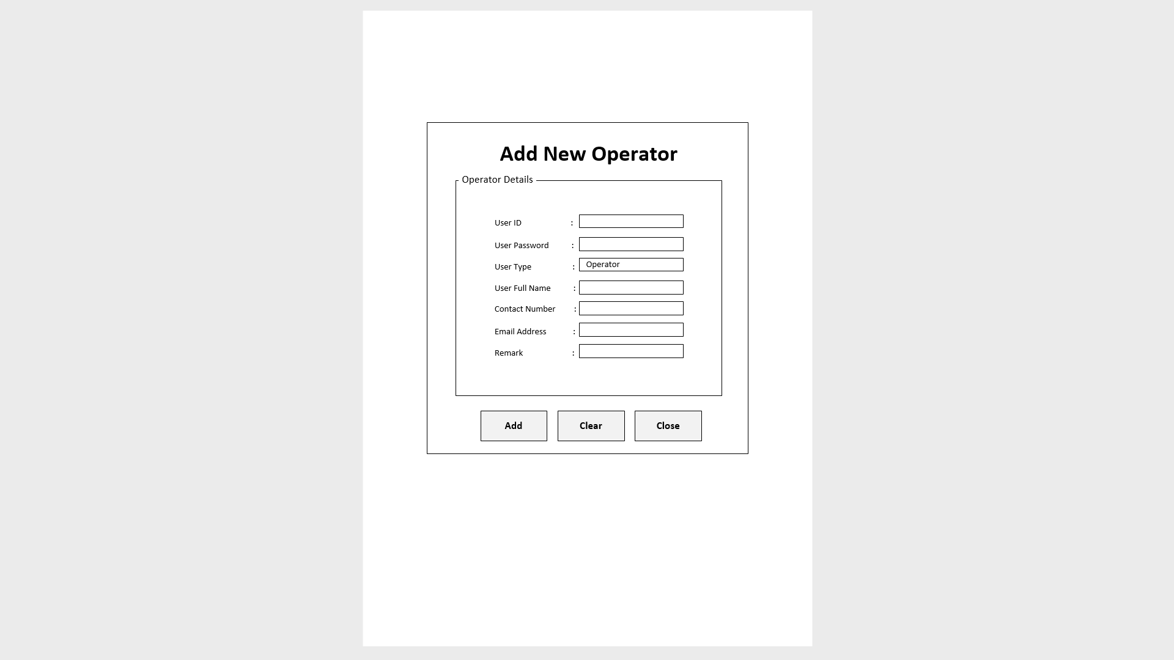

btnAdd

btnClear

btnClose

txtUserID

txtUserPw

lblOperator

txtUserName

txtContNumb

txtEmailAdd

txtRemarks

Flowchart

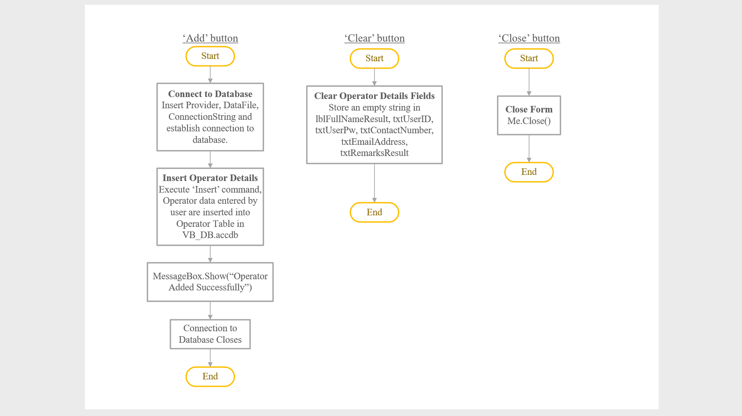

Explanation

This form is to add operators into the operator table in the database. Admin can enter operator details such as User ID, User Password, User Full Name, Contact Number, Email Address, and Remark into the textboxes. However, admin cannot modify the User Type because it is set as Operator in label form. The ‘Add’ button will add the details entered into the operator table in the database and display a message box saying “Operator Added Successfully”. ‘Clear’ button will reset all textboxes into blank and ‘Close’ button will close the form.

### 2.2.4 Edit Car Form

Storyboard

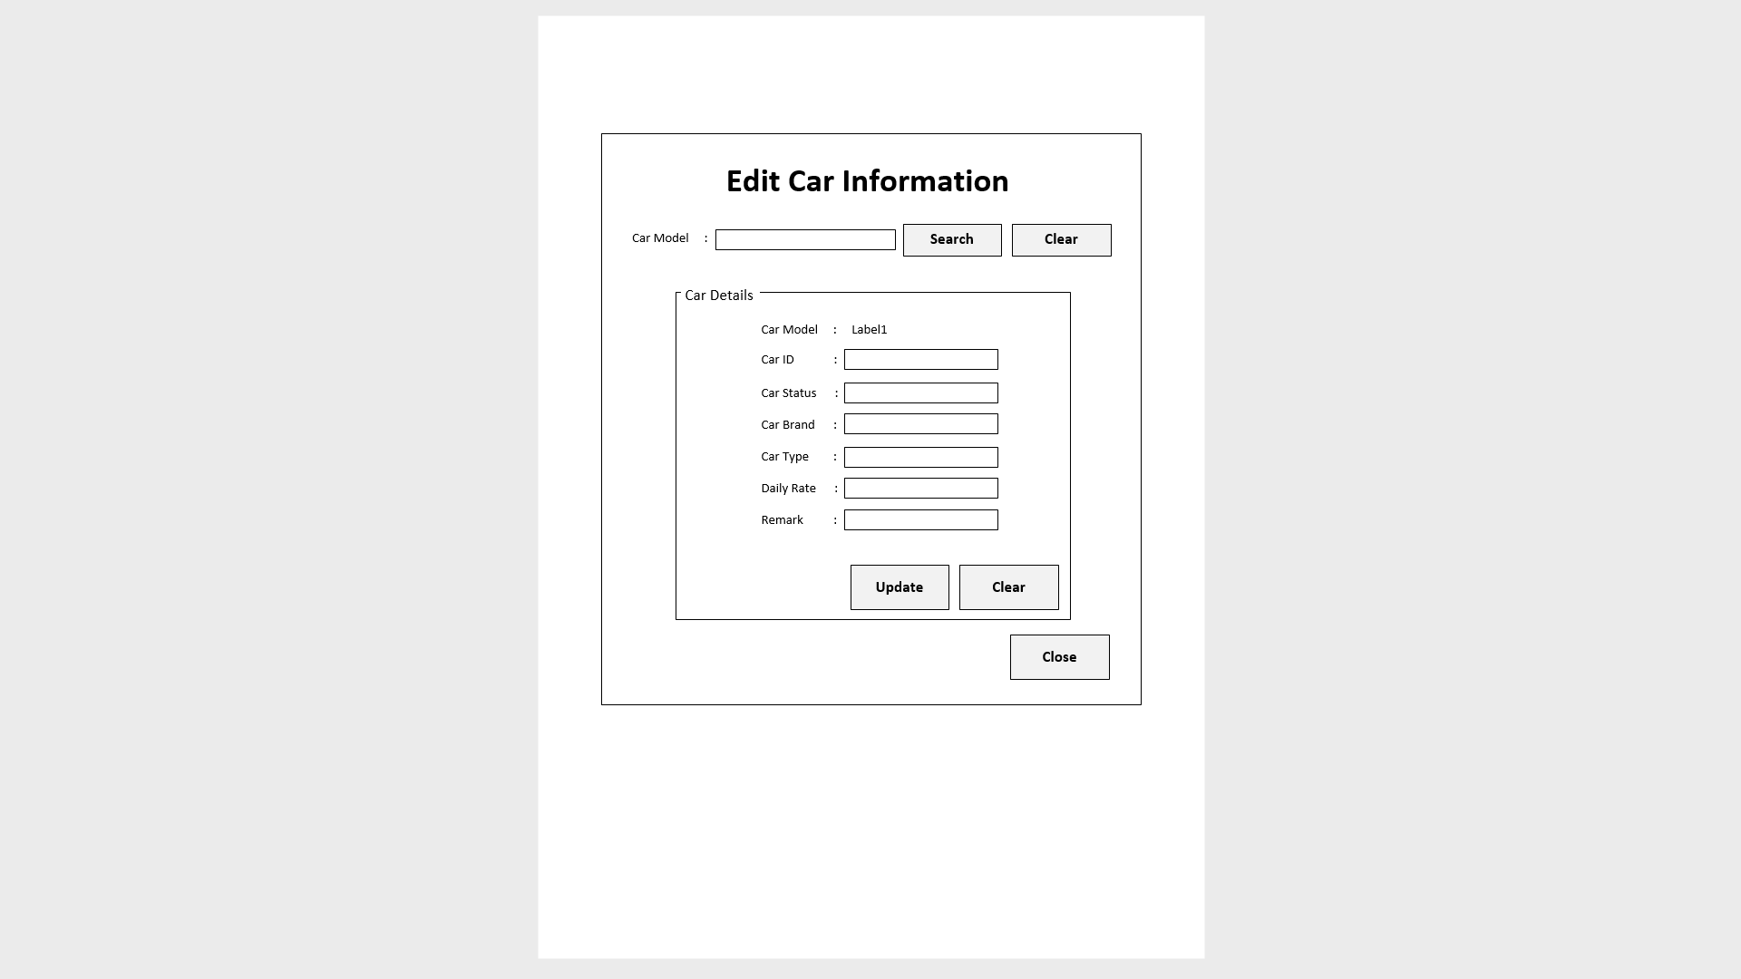

txtSearch

btnSearch

btnClear

btnUpdate

btnClear2

btnClose

lblCarModel2

txtCarID

txtCarStatus

txtCarBrand

txtCarType

txtDailyRate

txtRemarks

Flowchart

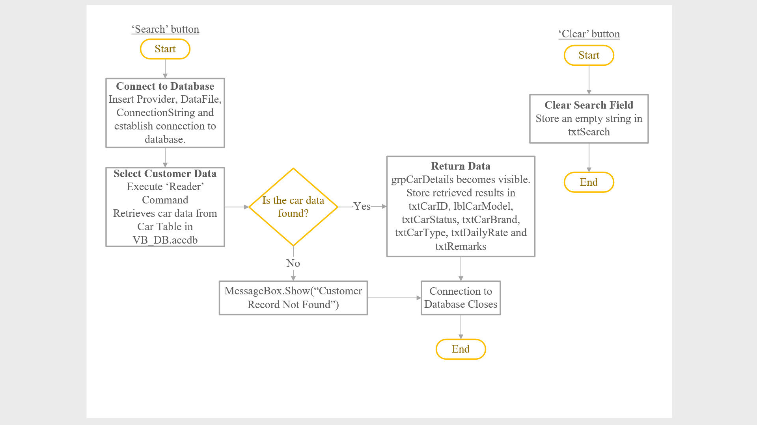

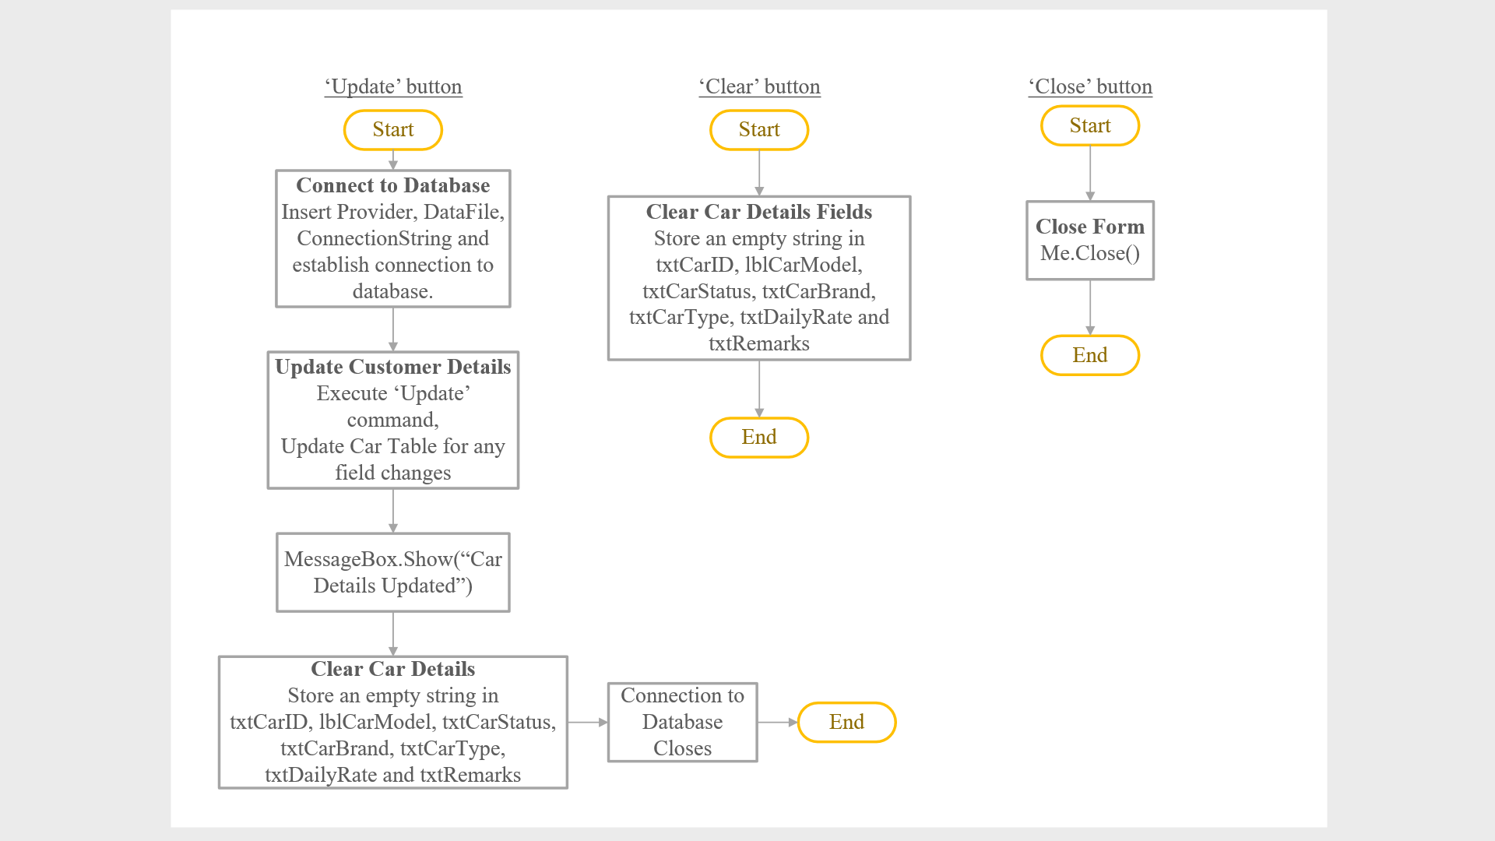

Explanation

This form is used to edit car information. When the form is loaded, the group box and everything in it are made invisible. There is a textbox at the top for user to enter the car model they would like to search for (by clicking the ‘Search’ button). User may clear the search textbox by clicking ‘Clear’ button next to ‘Search’ button. When the ‘Search’ button is clicked, it will look for the record in the database where the car model is as entered by user. If the record is found, it will retrieve the car details from the database and display it in the group box which becomes visible. If the record is not found, “Car Not Found” will be displayed in a message box. There are filled textboxes in the group box containing the car details results and user can modify them. The only car detail in the group box that is not editable is the car model result (lblCarModel2) because it is in the form of label. The Update button will update the information in the database with those entered by user in the textboxes and display a message box saying “Updated Successfully”. The Clear button will clear the textboxes and the Close button at the bottom can be clicked to close the form when there are no more changes.

### 2.2.5 Edit Operator Form

Storyboard

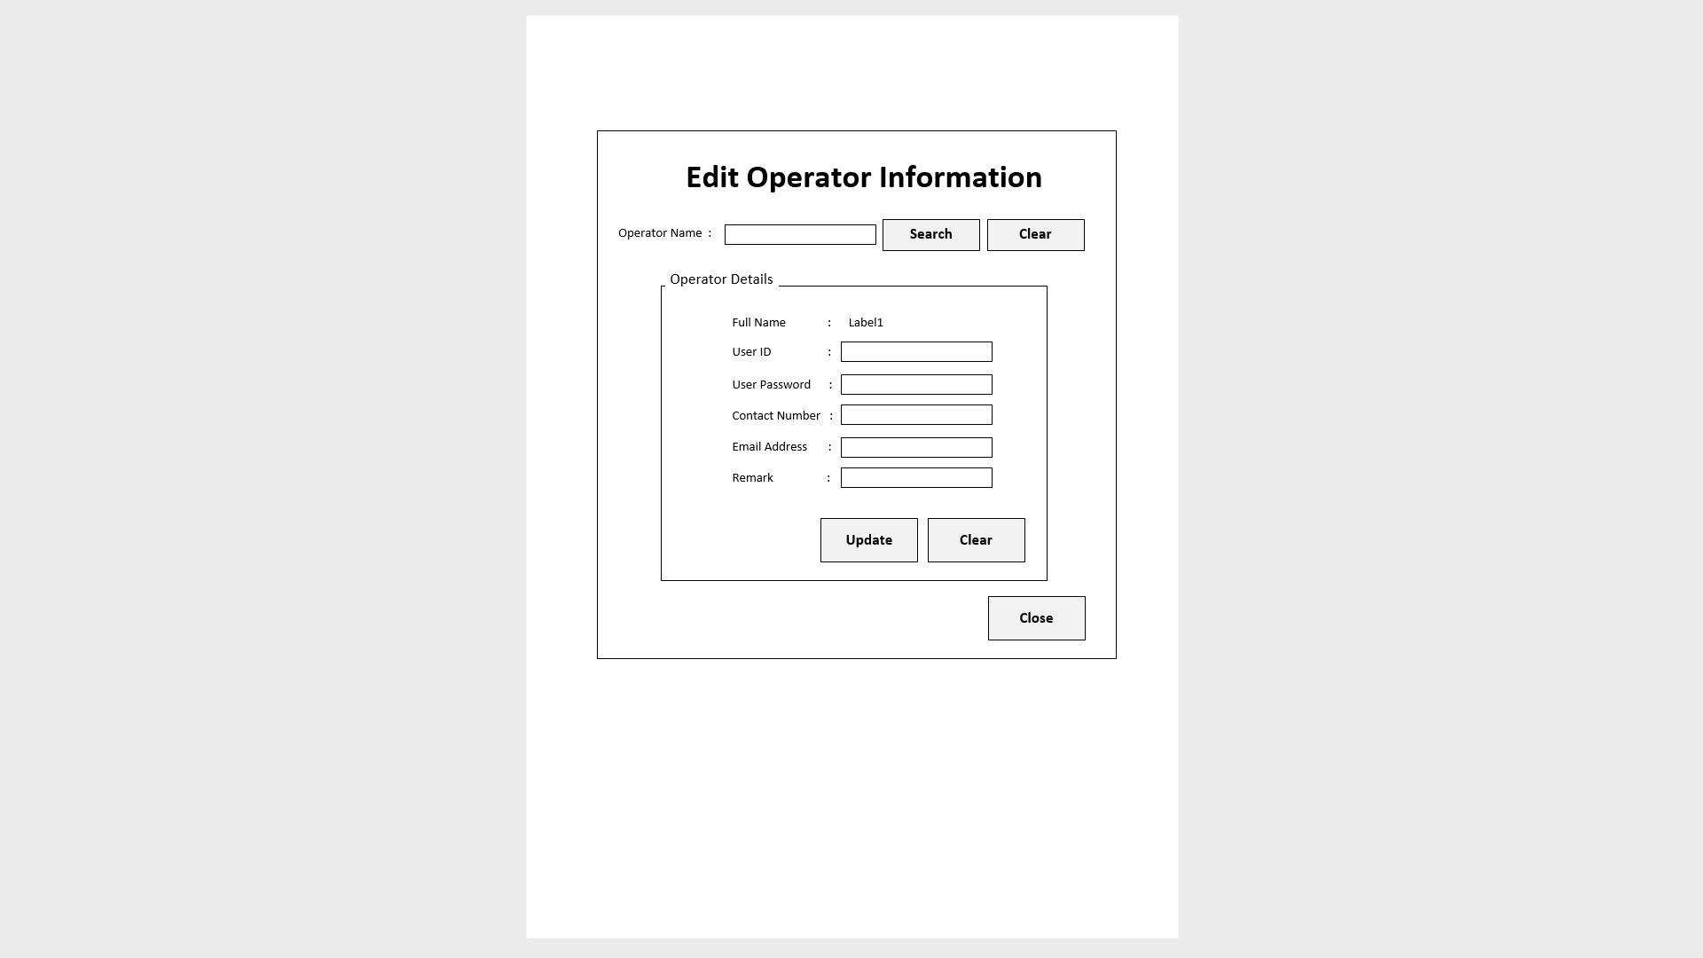

btnUpdate

btnClear2

btnClose

txtSearch

btnSearch

btnClear

lblFullNameResult

txtUserID

txtUserPw

txtContNumb

txtEmailAdd

txtRemarks

Flowchart

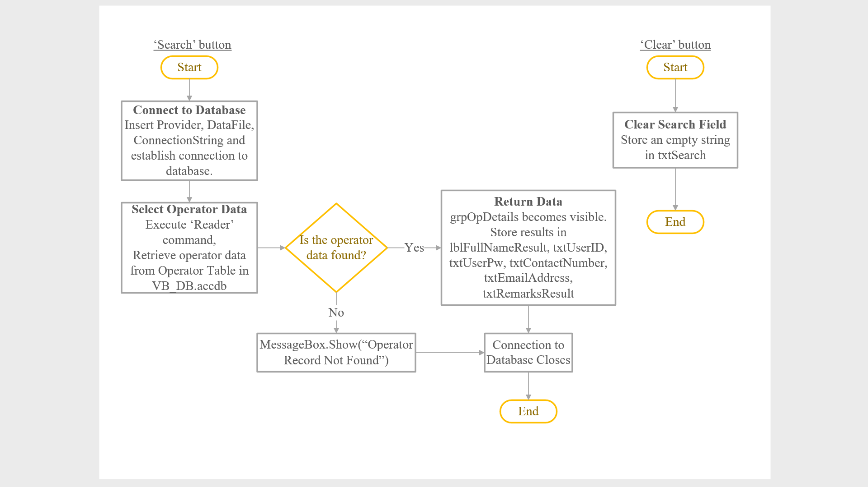

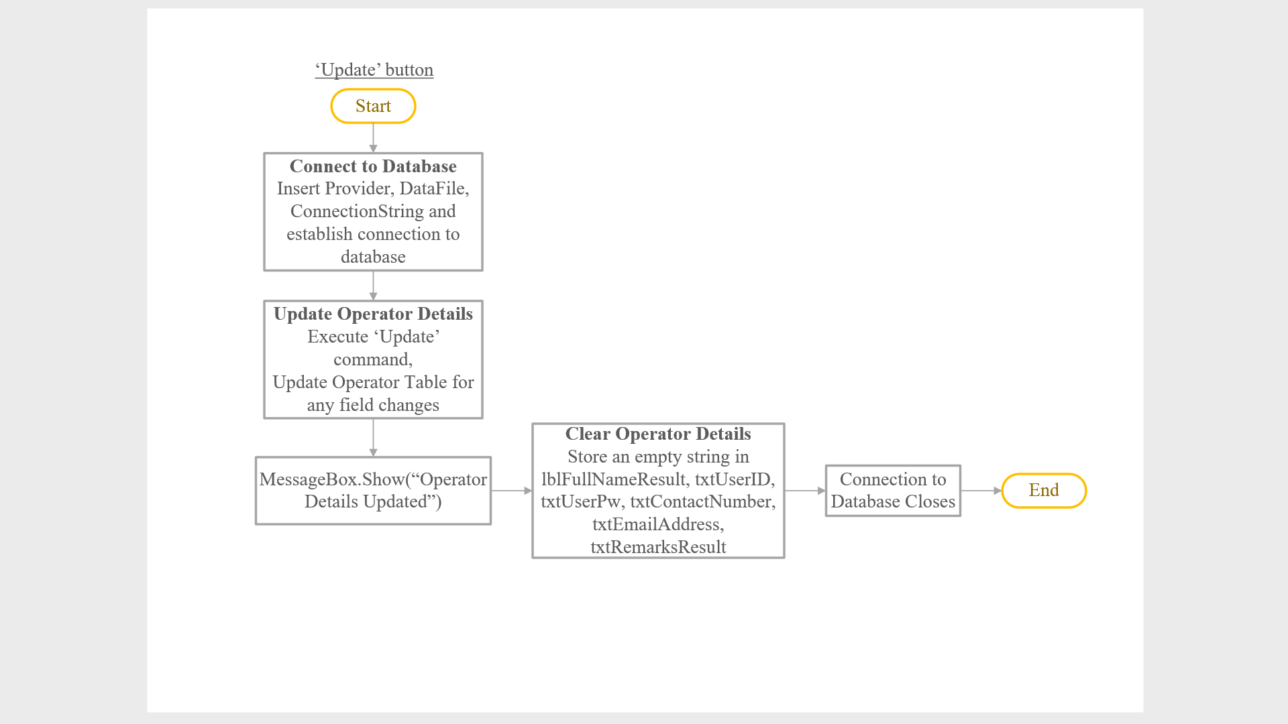

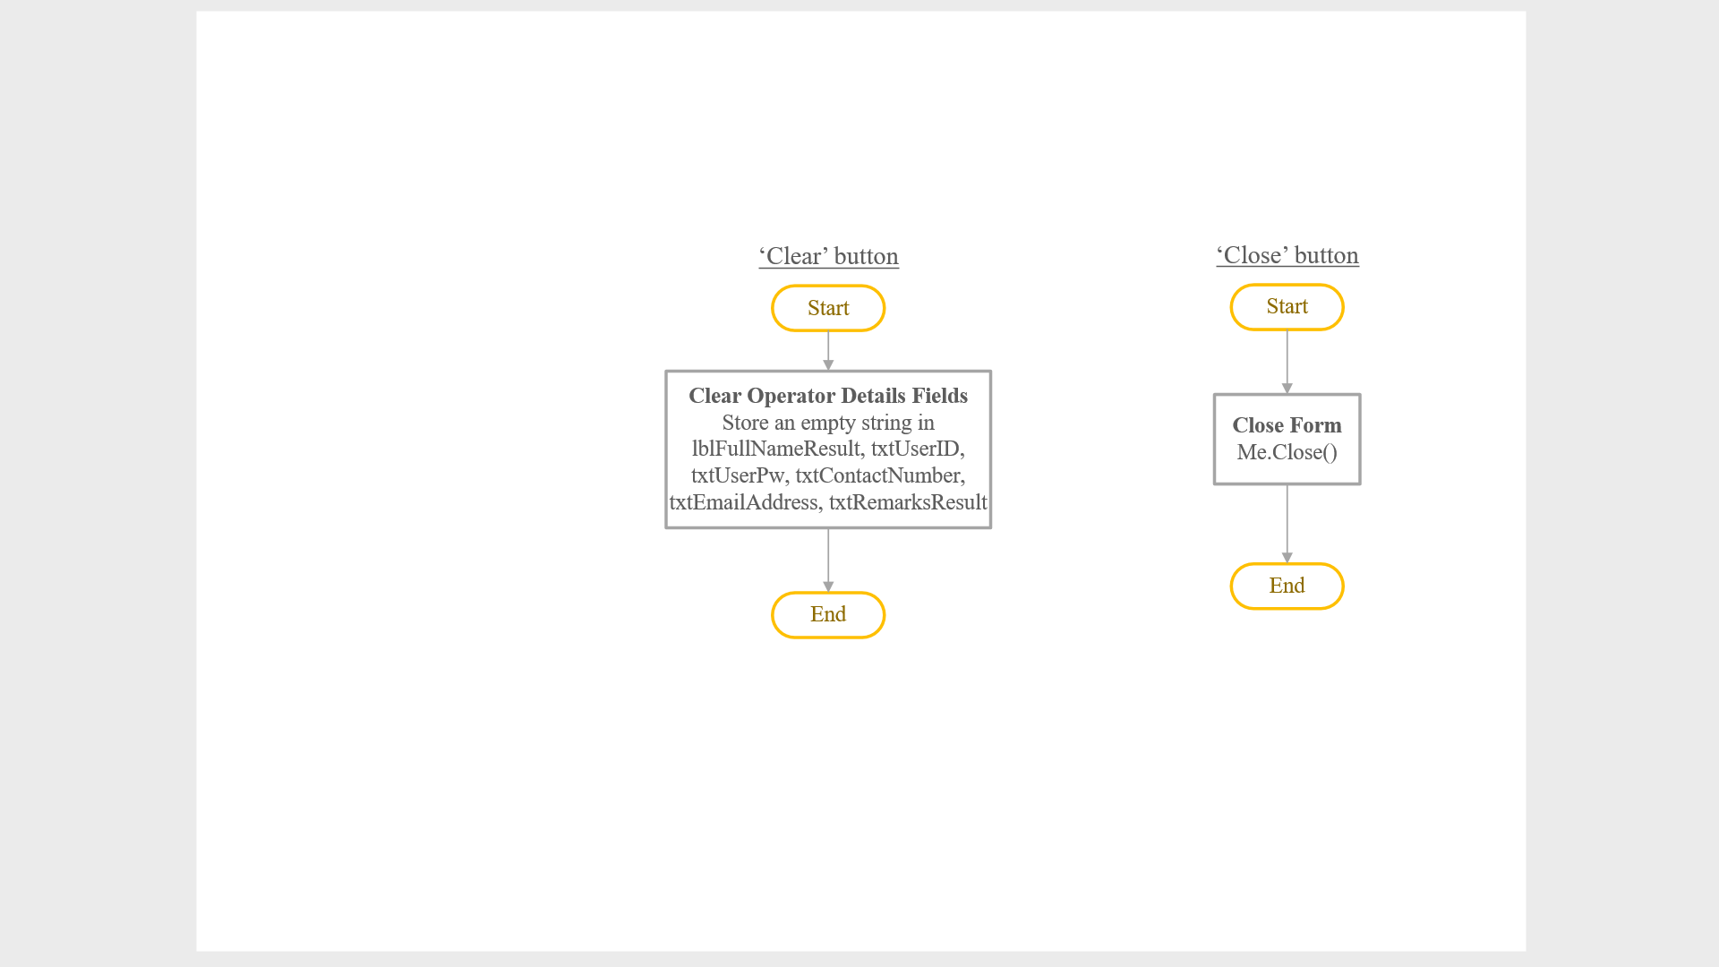

Explanation

This form is similar to Edit Car form whereby the only differences are the labels and the function of the Search and Update button. When the form is loaded, the group box and everything in it are made invisible. The Search button in this case will search in the operator table in the database for the record containing the operator name entered by user in the search textbox. Clear button is next to Search button for user to clear the search textbox. If the record is found, the operator details will be retrieved from the database and displayed in the group box which becomes visible. If record is not found, a message of “Operator Not Found” will pop up. Each detail except for Full Name comes with a textbox whereby user can edit the information. The Update button at the bottom of the group box will replace the data in the operator table in database with the data inside the textboxes in the form and display a message box saying “Updated Successfully”. User may click the Clear button to erase all data in the textboxes and click Close to exit the form.

### 2.2.6 Remove Car Form

Storyboard

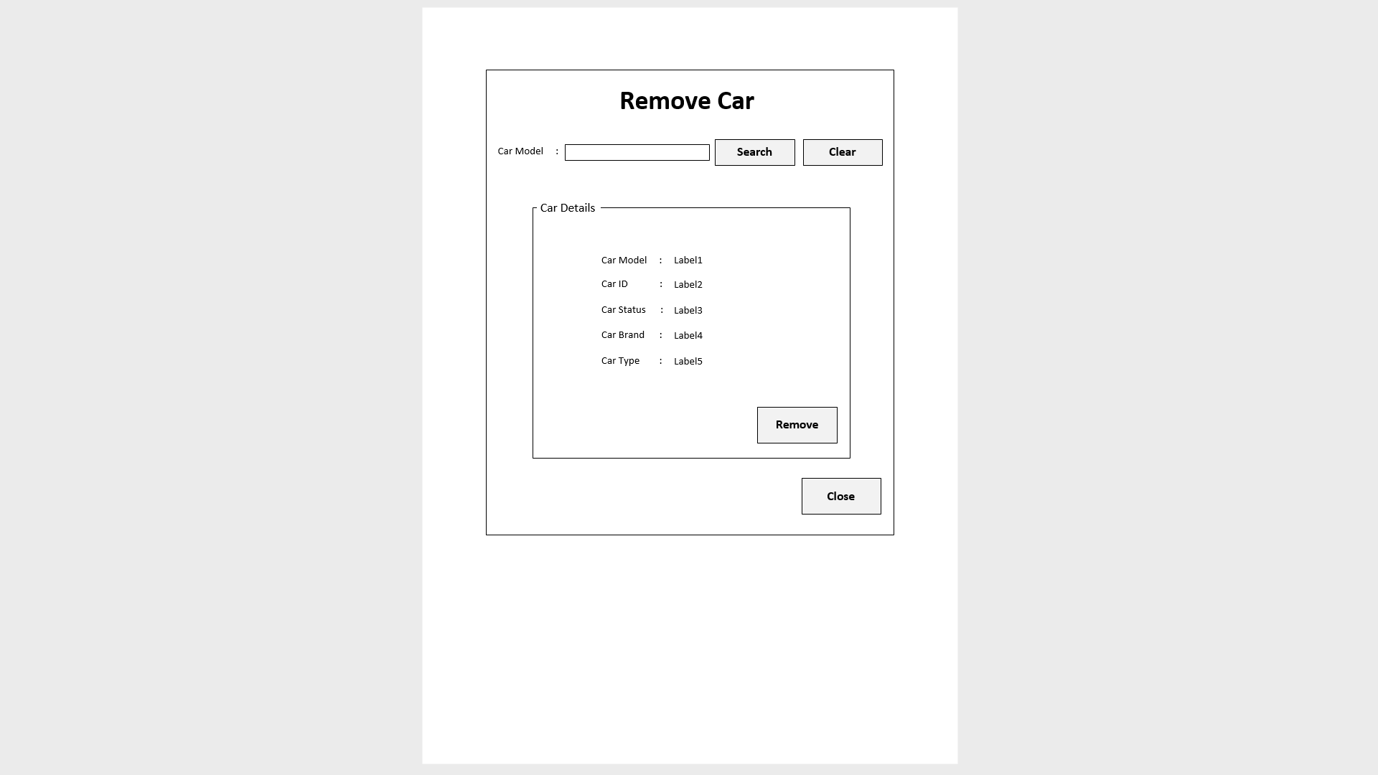

btnRemove

btnClose

txtSearch

btnSearch

btnClear

lblCarModel2

lblCarID2

lblCarStatus2

lblCarBrand2

lblCarType2

Flowchart

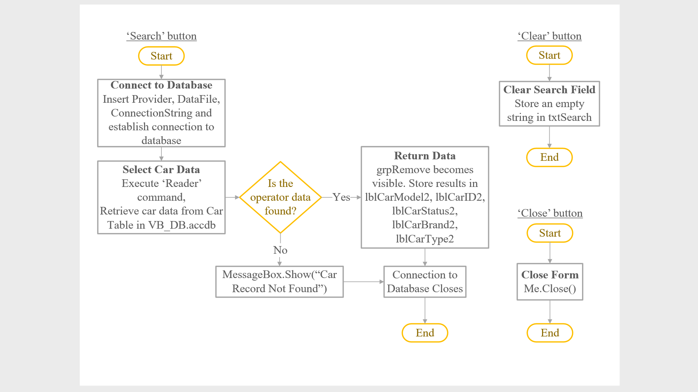

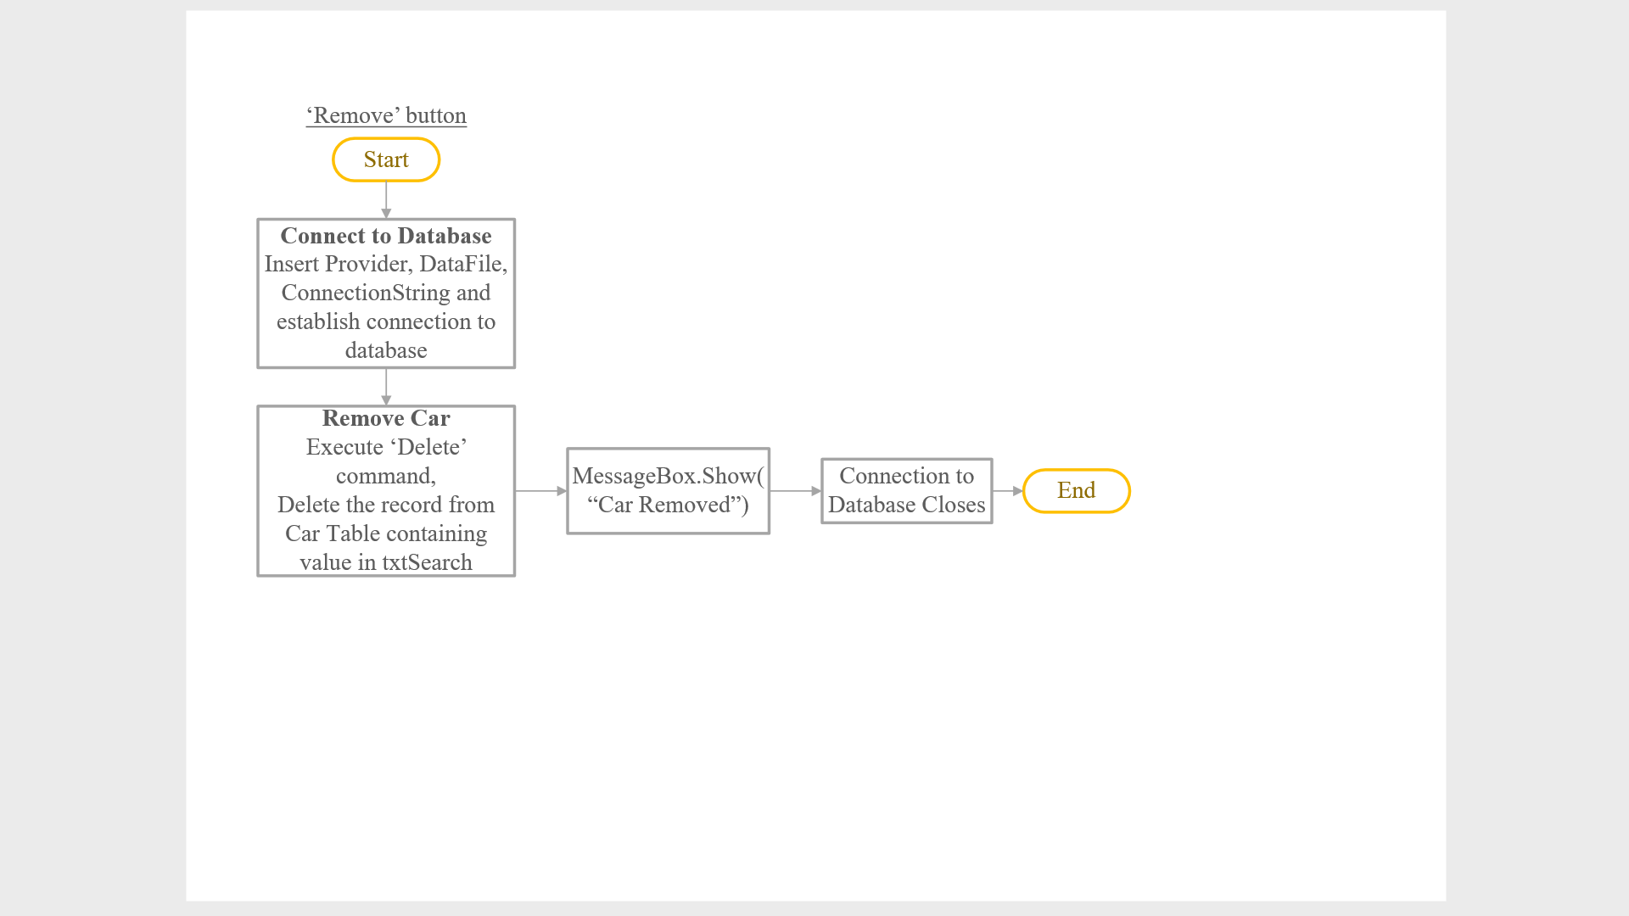

Explanation

This form allows admin to remove car from the database. When the form is loaded, the group box and everything in it are made invisible. Admin can fill in the car model that he/she would like to remove in the search textbox then click the ‘Search’ button which will look for and retrieve the data from the car table in the database. If the record is found, the car details results will be shown in the labels inside the group box which is made visible only once the record is found. But if the record is not found, a message box will show up saying “Car Not Found”. Admin is not allowed to edit the car details as they are displayed in label form for the sole purpose of clarifying that this is the car they would like to remove. Clicking the ‘Remove’ button which will delete that car’s record from the database and display a message “Car Removed”. If there are no more cars to be removed, admin can click the ‘Close’ button to exit the form.

### 2.2.7 Remove Operator Form

Storyboard

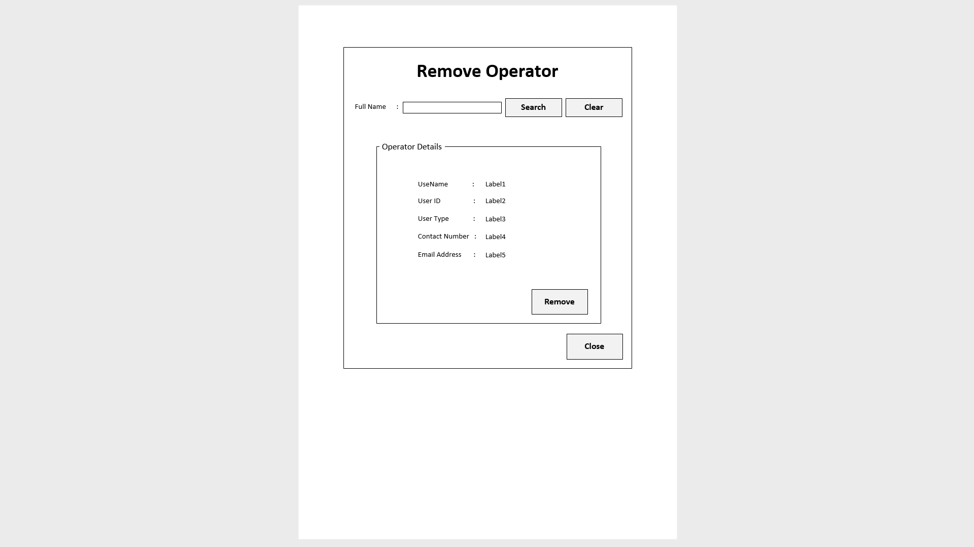

btnRemove

btnClose

txtSearch

btnSearch

btnClear

lblUserName2

lblUserID2

lblUserType2

lblContNumb2

lblEmailAdd2

Flowchart

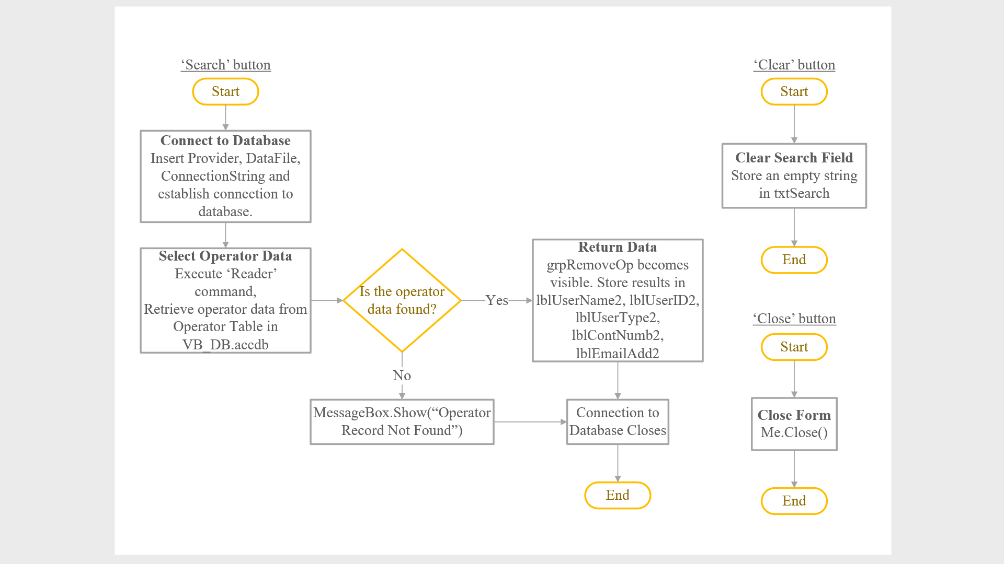

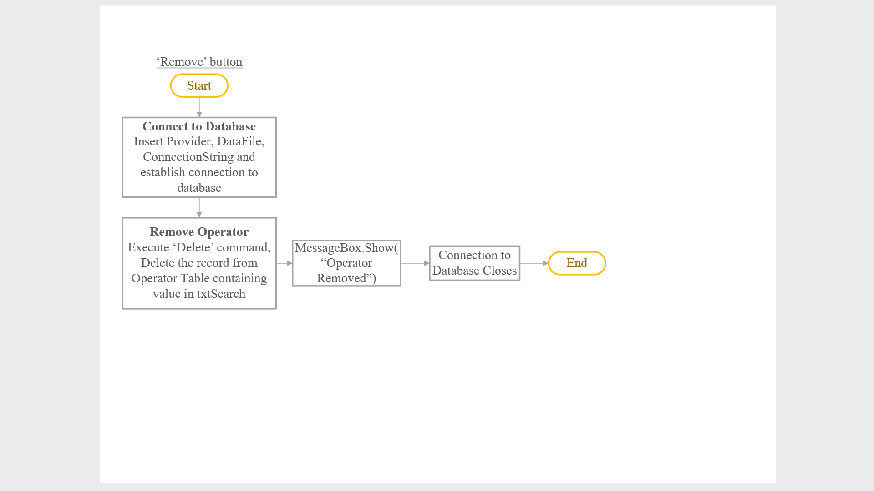

Explanation

This form allows admin to remove operator from the database which means that the removed operator will not be able to login and use the system again. When the form is loaded, the group box and everything in it are made invisible. Admin can fill in the operator’s full name that he/she would like to remove in the search textbox then click the ‘Search’ button which will look for and retrieve the data from the operator table in the database. If the record is found, the operator details results will be shown in the labels inside the group box which is made visible only once the record is found. But if the record is not found, a message box will show up saying “Operator Not Found”. Admin is not allowed to edit the operator details as they are displayed in label form for the sole purpose of clarifying that this is indeed the operator they would like to remove. The ‘Remove’ button will delete that operator’s record from the database and show a message box saying “Operator Removed” whilst the ‘Close’ button will exit the form.

## 2.3 Operator Interface

### 2.3.1 Operator Menu Form

Storyboard

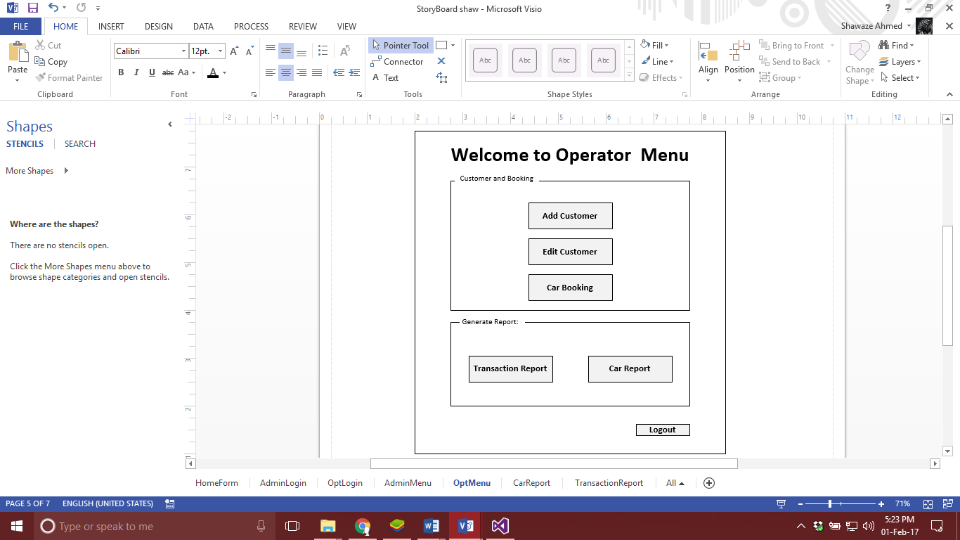

btnCarBook

btnEditCustomer

btnAddCustomer

btnCarRpt

btnTranRpt

btnLogout

Flowchart

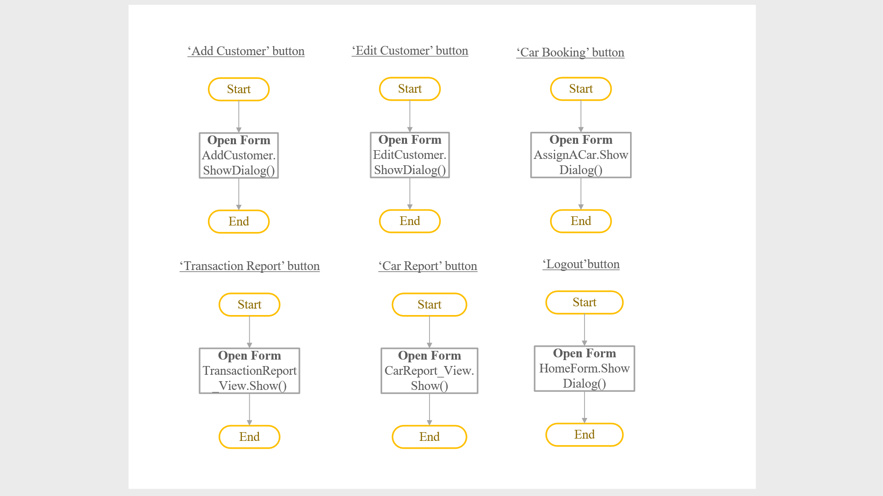

Explanation

This Form is operator menu, which allows operator to choose what task he/she wants to perform. The menu includes buttons that are grouped into two, first one is ‘Customer and Booking’ and the second one is ‘Report Generator’. The buttons that are provided are Add Customer, Edit Customer and Car Booking that lead to different forms related to customer and assigning a car. Last two buttons lead to different reports that are generated once clicked by operator.

### 2.3.2 Add Customer Form

Storyboard

btnAdd

txtEmailAdd

txtCustID

txtFirstName

txtLastName

txtContNumber

txtFullAdd

btnClear

btnClose

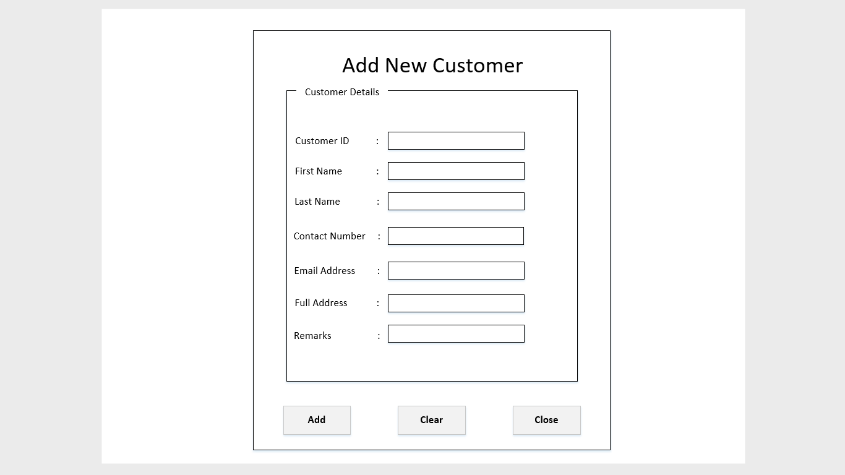

txtRemarks

Flowchart

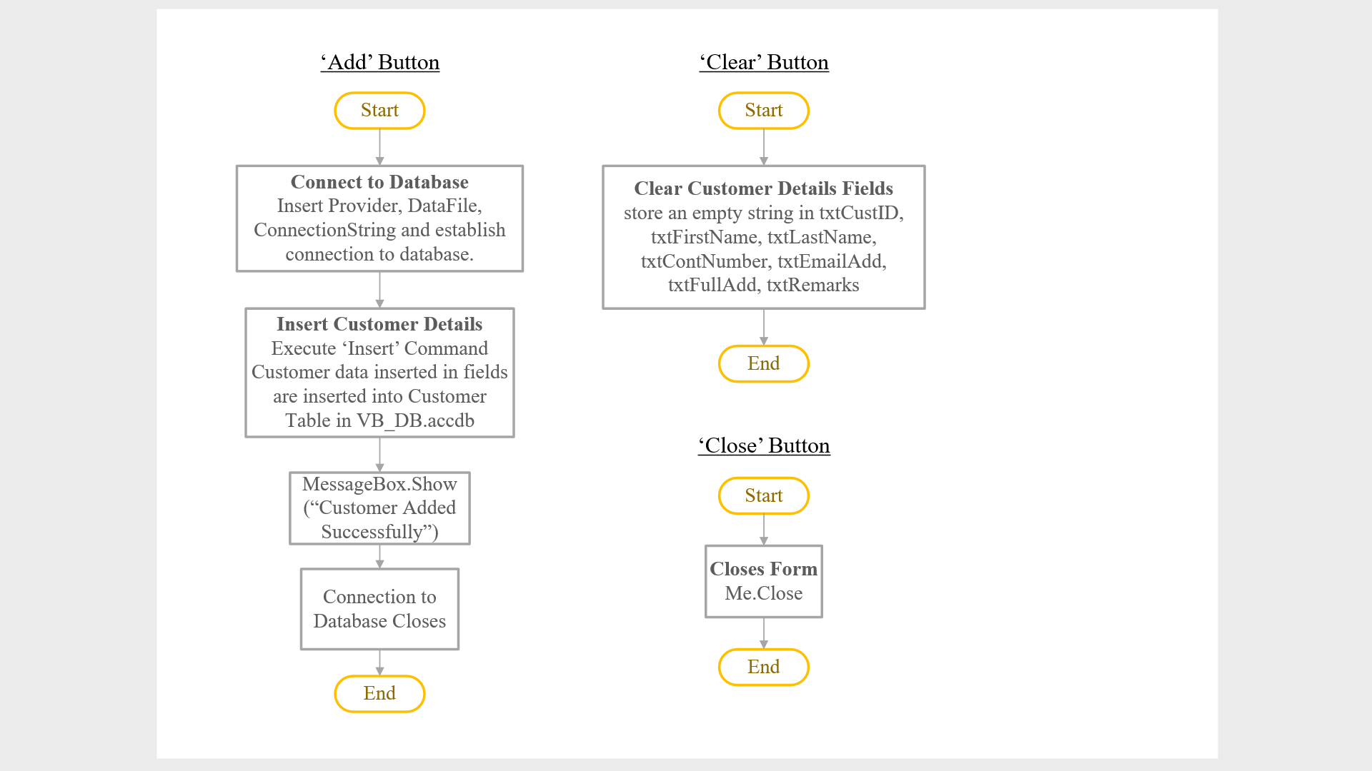

Explanation

This form is for the user type, operator in which he/she has the authority to add customers into the system, if there are any new walk-in customers wanting to rent a car. From the figure above, the operator must type in the customer’s ID (identity card or passport number of the customer), first name and last name, contact number, e-mail address, full address (home address) and remarks made by customer (optional to fill in). Once all the fields have been filled, the operator will click the button ‘Add’ to insert the data into the Customer’s table in the database. Once data has been inserted, the fields can be cleared by clicking the ‘Clear’ button. If there are no more changes, the form will be closed using the ‘Close’ button.

### 2.3.4 Edit Customer Form

Storyboard

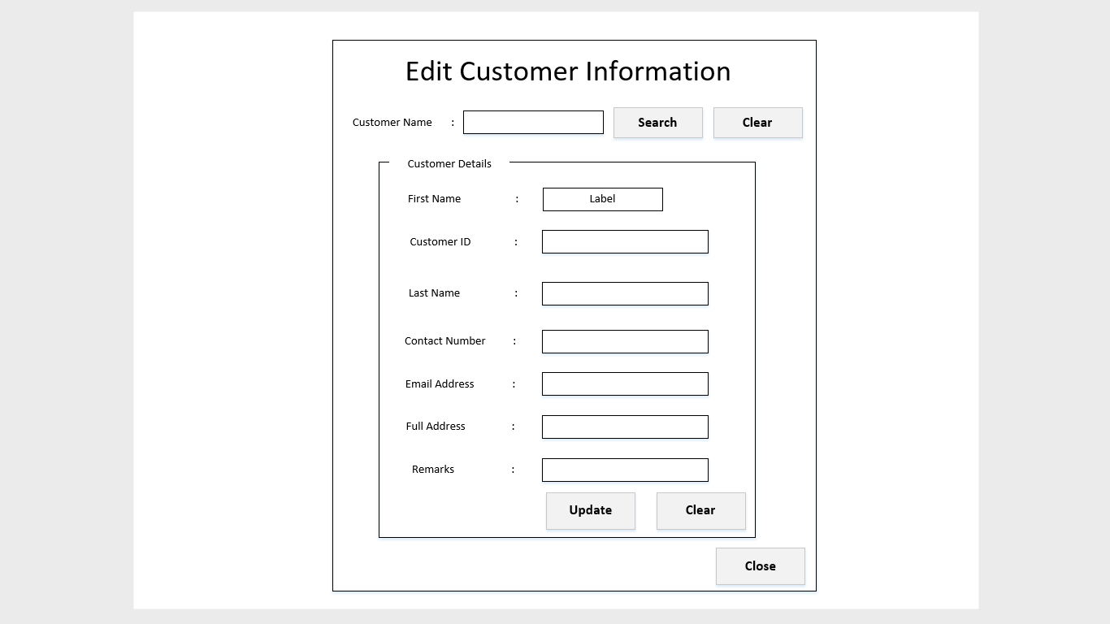

btnClear2

btnSave

btnClose

txtRemarksResult

txtFullAddress

txtEmailAddress

txtContactNumber

txtLastNameResult

lblFirstNameResult

txtCustomerID

btnClear

btnSearch

txtSearch

Flowchart

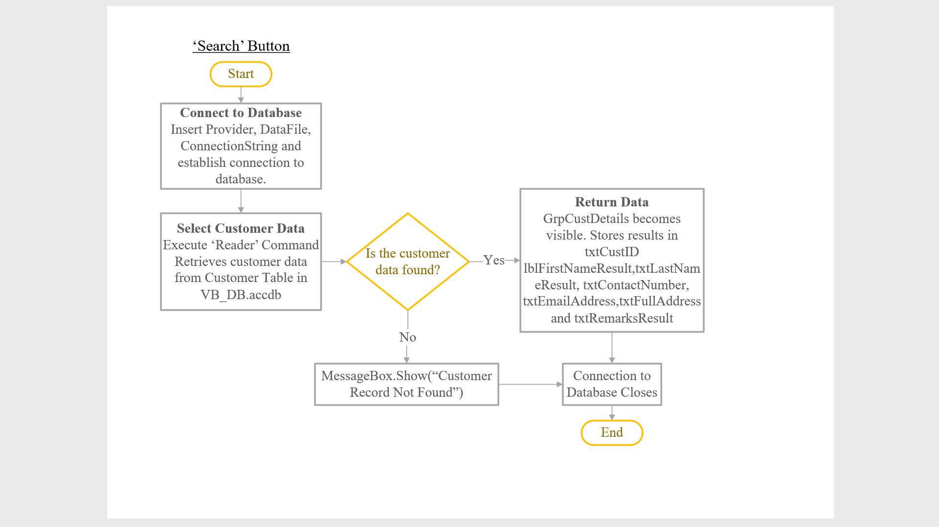

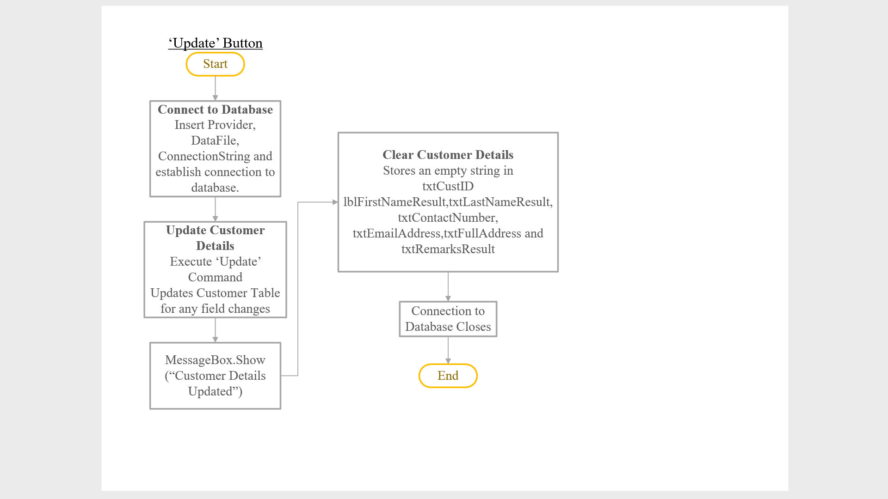

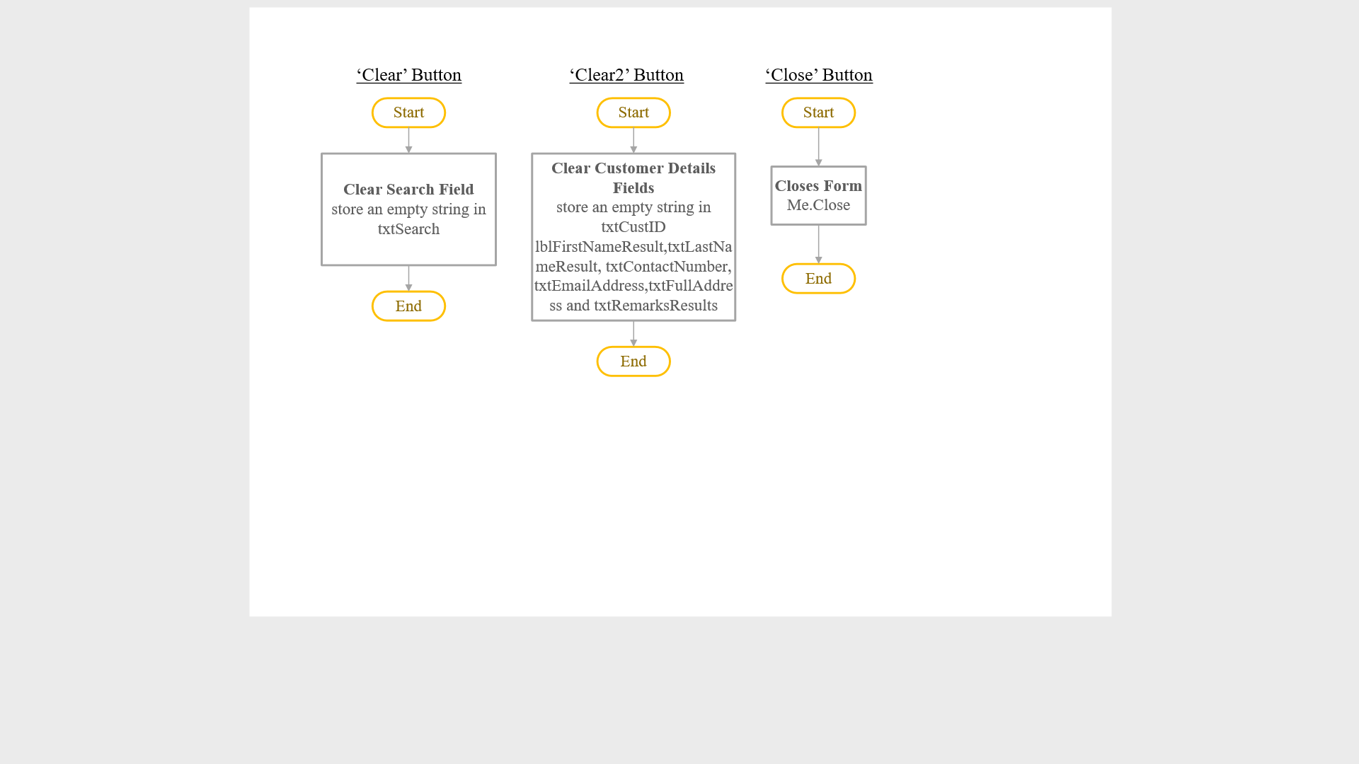

Explanation

This form allows the operator to edit customer’s information from the database. From the above figure, the user has to type in the customer’s name in the search textbox. Once the search button is clicked, the system would retrieve the customer’s data from the database. If data is found, it will return the results in the fields of the customer details. All of the other fields such as customer ID, last name and contact number are in the form of textbox which is editable. Except for the first name field which is in the form of label where it is not editable. If the all of the fields need to be reset, the user will click the ‘Clear’ button. Otherwise, if changes have been made, the ‘Update’ button will be clicked. If there are no more changes to be made, the form will be closed by clicking the ‘Close’ button.

### 2.3.5 Search to Assign Form

Storyboard

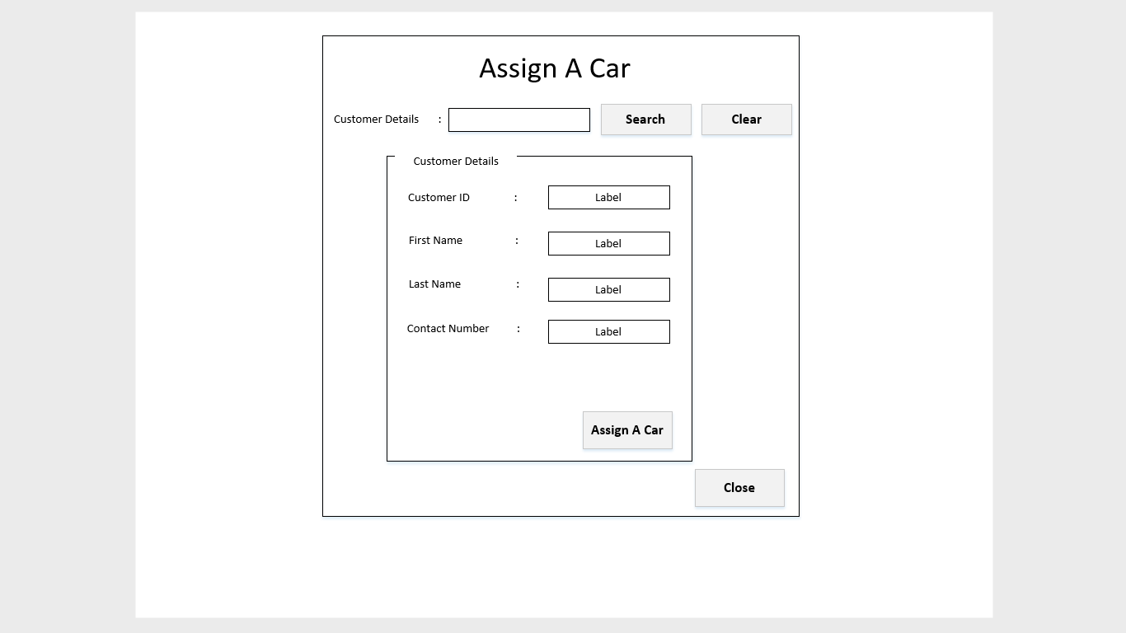

btnAssignACar

btnClose

lblCustomerIDResult

lblFirstNameResult2

lblLastNameResult2

lblContactNumberResult2

txtSearch2

BtnSearch2

BtnClear2

Flowchart

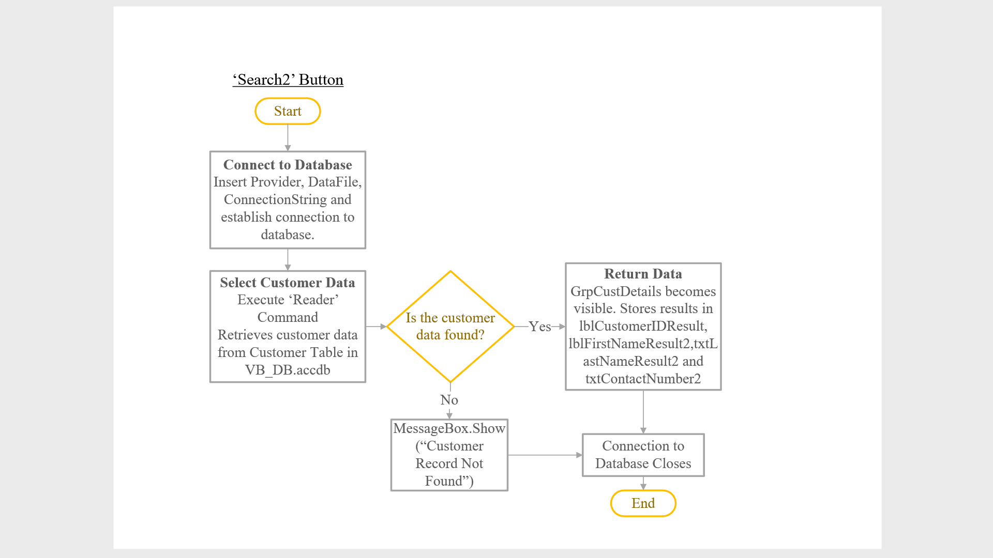

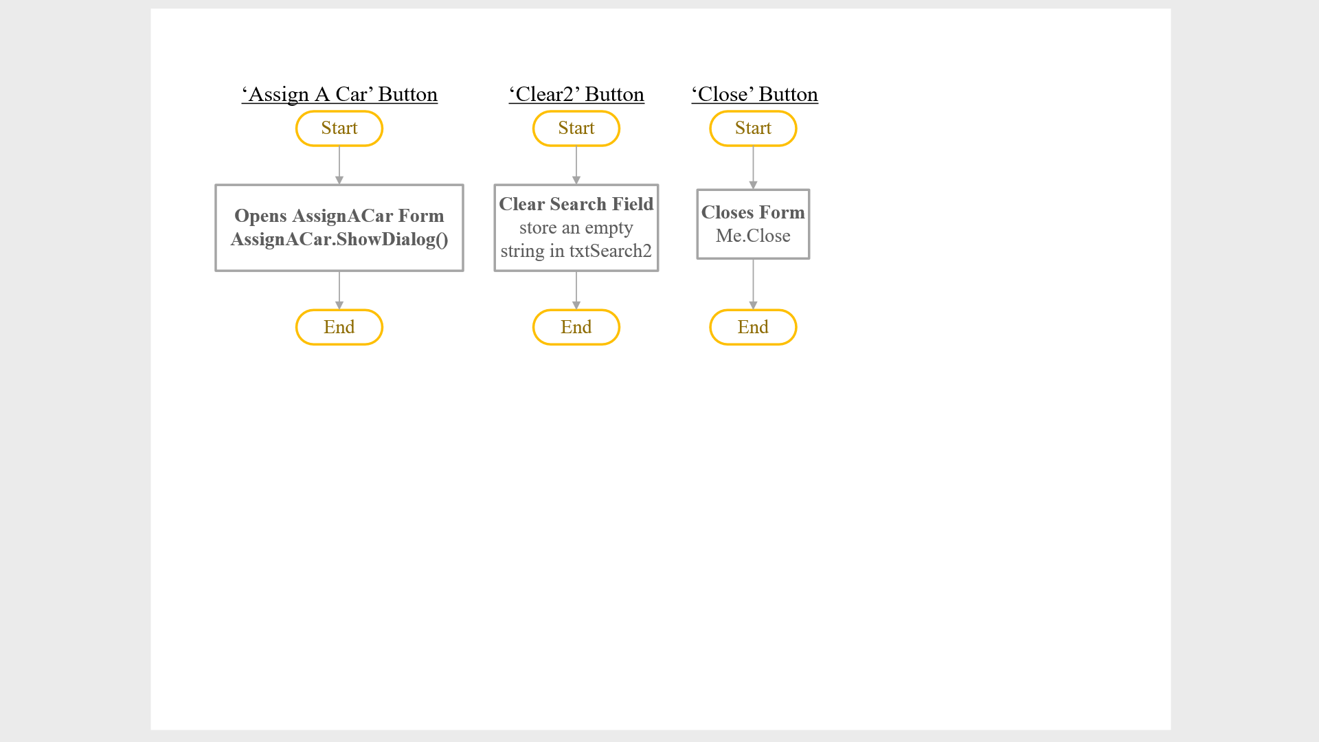

Explanation

This form allows the operator to search for an existing customer in order to assign a car for them. From the figure above, the operator must search for the customer’s data by entering any field such as the first name or last name. Once ‘Search’ button has been clicked, the customer’s details will appear and the following fields; customer ID, first name, last name and contact number will appear in the form of label as it is not editable. Once customer’s details have been confirmed, the ‘Assign A Car’ button can be clicked, which redirects the user to another form. Otherwise, if there is no need to assign a car, the form will be closed, by clicking the ‘Close’ button.

### 2.3.6 Assign A Car Form

Storyboard

btnLoad

lblCustomerIDResult

lblFirstNameResult2

lblLastNameResult2

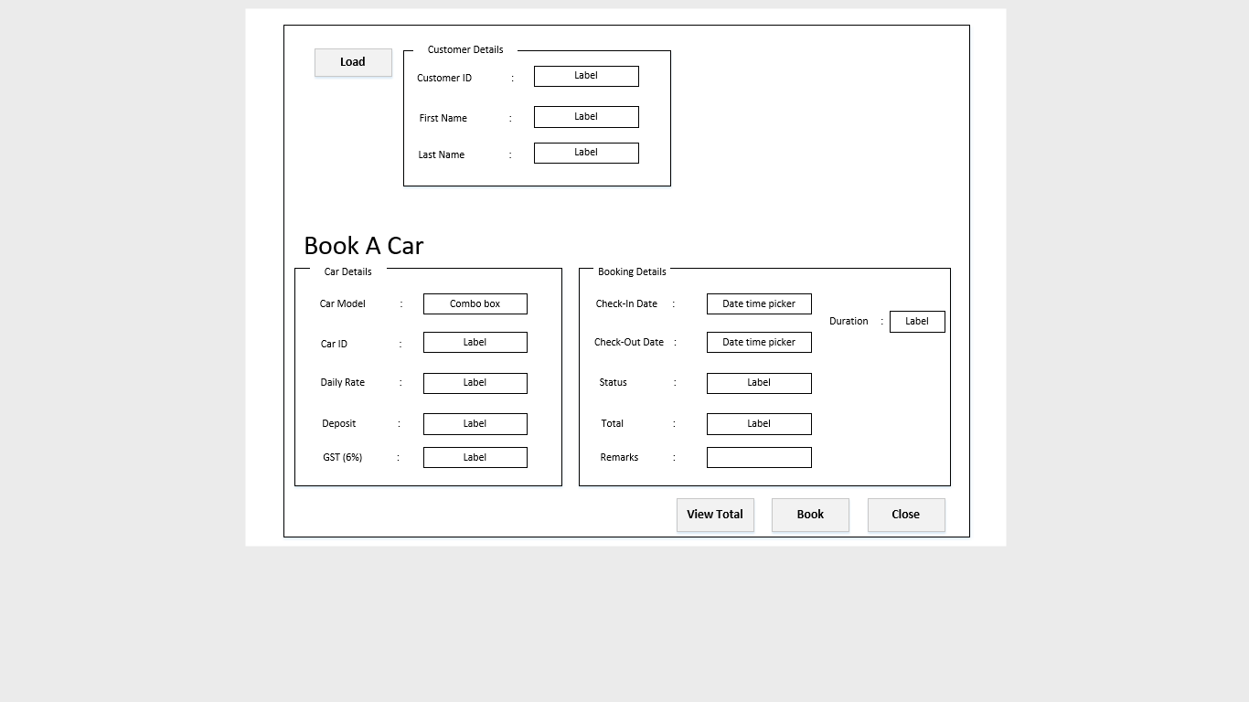

btnClose

btnBook

btnViewTotal

cboCarModel

lblCarID

lblPriceResult

lblDeposit

lblGstResult

dtCheckInDate

lblduration

dtCheckOutDate

lblStatus

lblTotal

txtRemarks

*Figure 1: Storyboard of Assign a Car form*

Flowchart

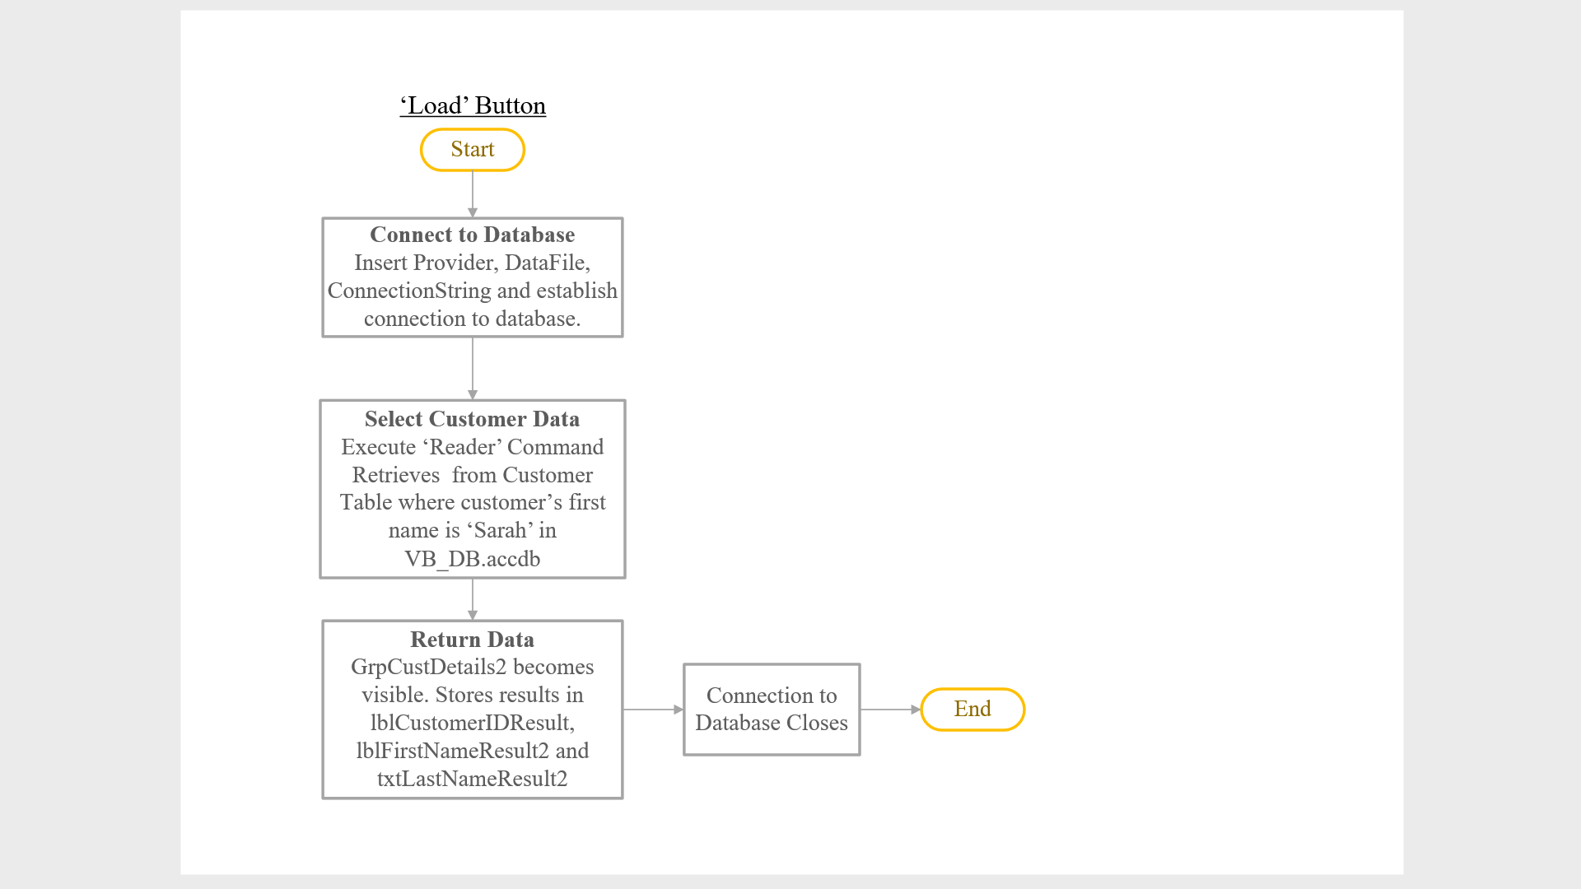

*Figure 1: Flowchart of ‘Load’ button*

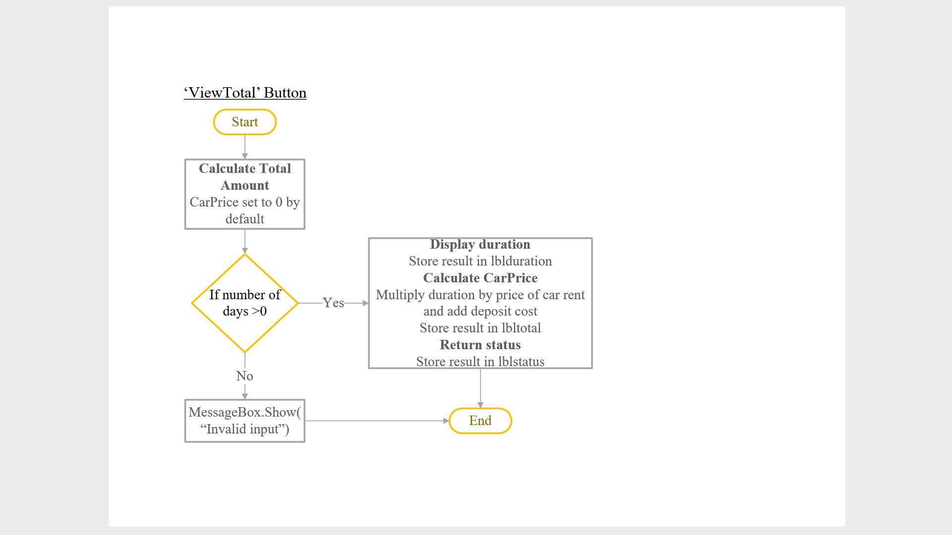

*Figure 1: Flowchart of ‘View Total’ button*

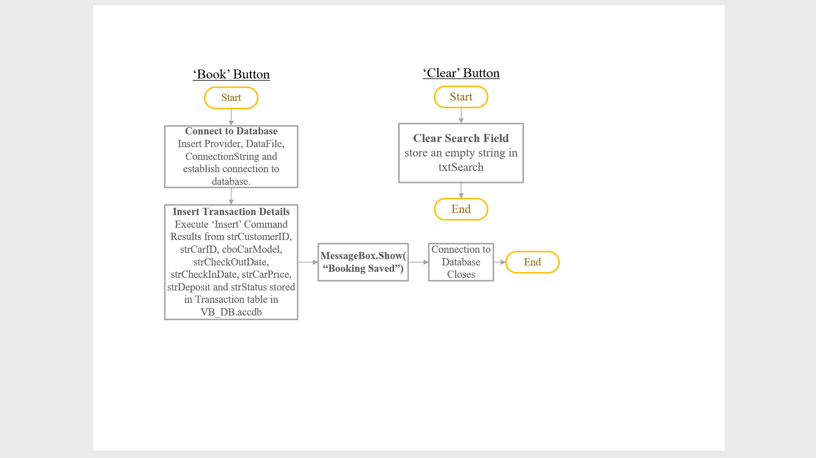

*Figure 1: Flowchart of ‘Book’ button and ‘Clear’ button*

Explanation

This form allows the operator perform bookings for customers who wants to rent a car. From the above figure, the operator would load the customer’s details first after he/she has successfully search the customer’s data in the previous form by clicking the ‘Load’ button, in which the customer’s details will appear; customer ID, first name and last name. After loading, the operator will proceed in to choosing the car model that customers would prefer, under the car details. Once a model has been chosen, the system will display the car ID, daily rate, deposit costs and the tax (GST 6%) for rent.

If car model is confirmed, the user will proceed to booking details where the operator would select the check-in and check-out date according to the customer’s preference. Once day and date has been set, the user would click the ‘View Total’ button, which will display the duration of the car being rented, the status and total amount to be paid. Remarks can be given by the customer if necessary.

Once car details and payment has been confirmed, the operator will proceed with the booking process in which the transaction information will be stored in the transaction table in the database, and booking is saved.

# 3.0 Report Design

## 3.1 Car Report

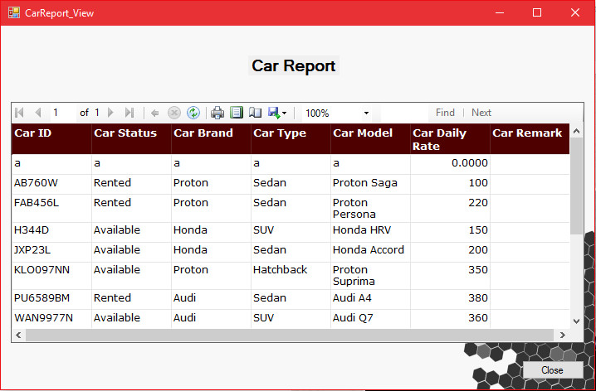

*Figure 1: Car Report form*

This form displays the car report, it allows the operator to view the report which is linked directly from the database as well and displayed on the system. The report view allows the operator to print the page if he/she wishes to or export the report; however it does not allow the operator to make changes directly from the report viewer but reports shown are updated if any changes are made in the database. The car table provides operator with car information such as car ID, car type, brand and status. It also displays the rate of each car per day which depends on which car it is. Operator can also write down car remarks if he/she wants to be reminded of something about the car. Once the operator is done viewing the report he/she can close the report form by clicking on the close button at the bottom right corner.

## 3.2 Transaction Report

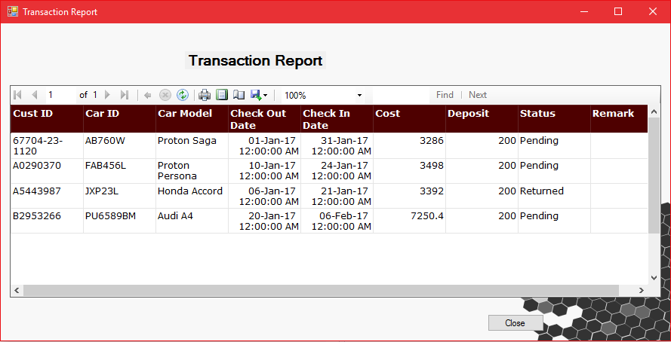

*Figure 1: Transaction Report*

This is transaction report, it allows the operator to view transaction table from the database linked directly into the system. The report only allows the operator to view the report hence the operator cannot edit or remove information from it; however if the operator wants to print the report he/she can do so by clicking on the print button provided in the menu bar above the table. The transaction table shows the transactions made by the system, it therefore displays the customer ID who rented the car, car ID, car model and the check in and out date. It calculates the cost depending on the days it is rented for times the cost per day following by the GST rate which is 6%. Apart from that it shows the deposit made by the customer and the status of the car whether it is pending or returned. This report is updated automatically if there are any new transactions made into the database. Once the operator is done viewing the report he/she can close the report form by clicking on the close button at the bottom right corner.

# 4.0 User Manual

## 4.1 Login

### 4.1.1 Home Form

*Figure 1: Home form*

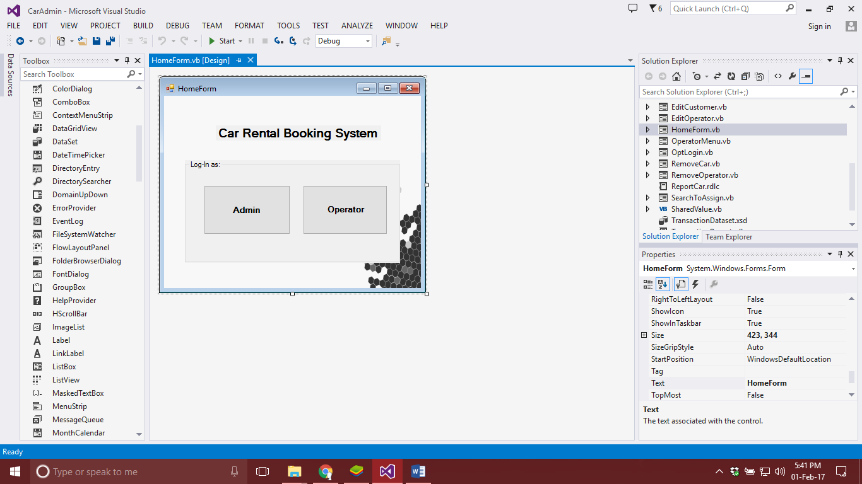

Choose the User Type to login as

This is the first form that user will get to see when they start up the system. This form has two choices provided to the user to select from ‘Admin’ or ‘Operator’. If the user clicks on the admin button it will direct the user to admin log-in form and same goes for operator button.

### 4.1.2 Admin Login

*Figure 1: Admin Login form*

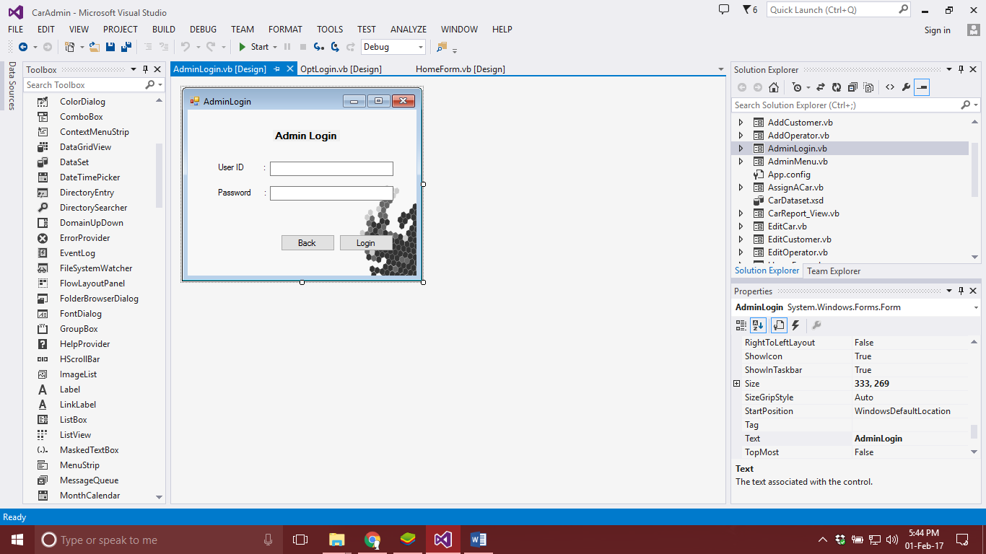

Step 1: Fill in the credentials

Step 2: Click Login

This is Admin login form, once the user clicks on the admin button from home form, the user is directed to this form. User is then required to fill in the correct User ID and Password to be able to access the admin form. Once the user has entered the credentials, the user can then click on log in button or else the user can click on back button to go back to home form.

### 4.1.3 Operator Login

*Figure 1: Operator Login form*

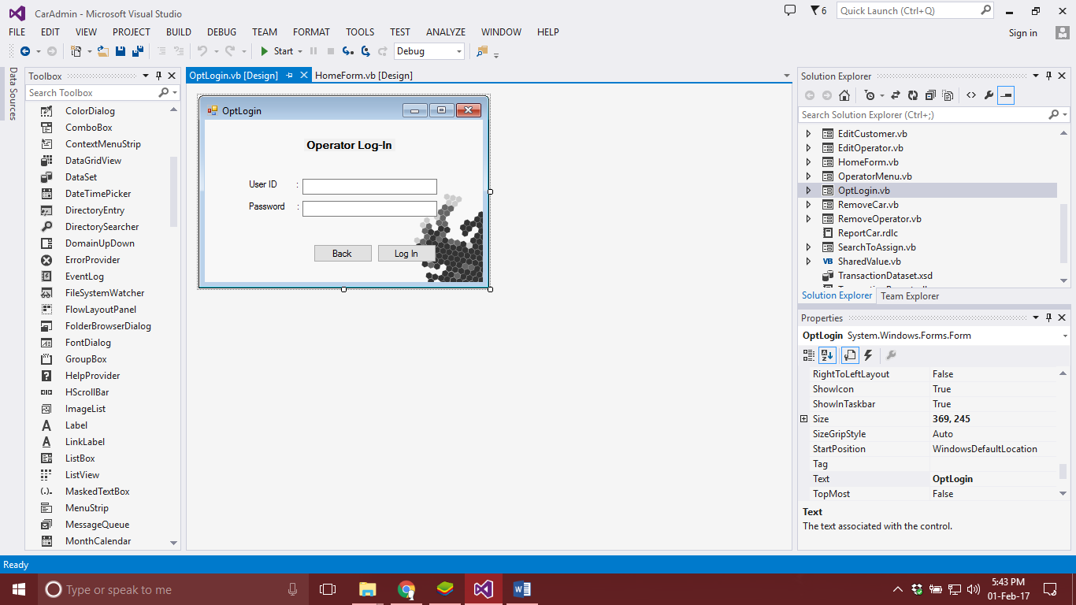

Step 1: Fill in the credentials

Step 2: Click Log In

This is Operator login form that is shown after the user clicks on the operator button in Home Form. This form requires the user to add in their credentials to be able to log in and access the operator menu and to be able to perform task. Once the user has entered the credentials, the user can then click on log in button or else the user can click on back button to go back to home form.

## 4.2 Admin Interface

### 4.2.1 Admin Menu Form

*Figure 1: Admin Menu form*

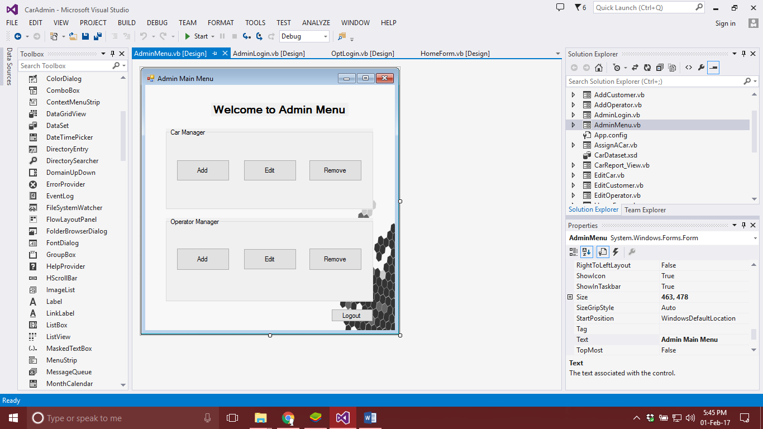

Step 1: Choose Add, Edit or Remove car

Step 2: Choose Add, Edit or Remove operator

Step 3: Logout

This form shows the admin menu, once the user has logged in successfully the user has the access to admin roles where buttons are provided for each task that can be performed by the admin. The admin can select to Add, Edit and Remove car or operator by clicking on the specific buttons. If admin wishes to logout, he/she can simply click on the button at bottom right corner ‘Logout’ to exit the menu.

### 4.2.2 Add Car Form

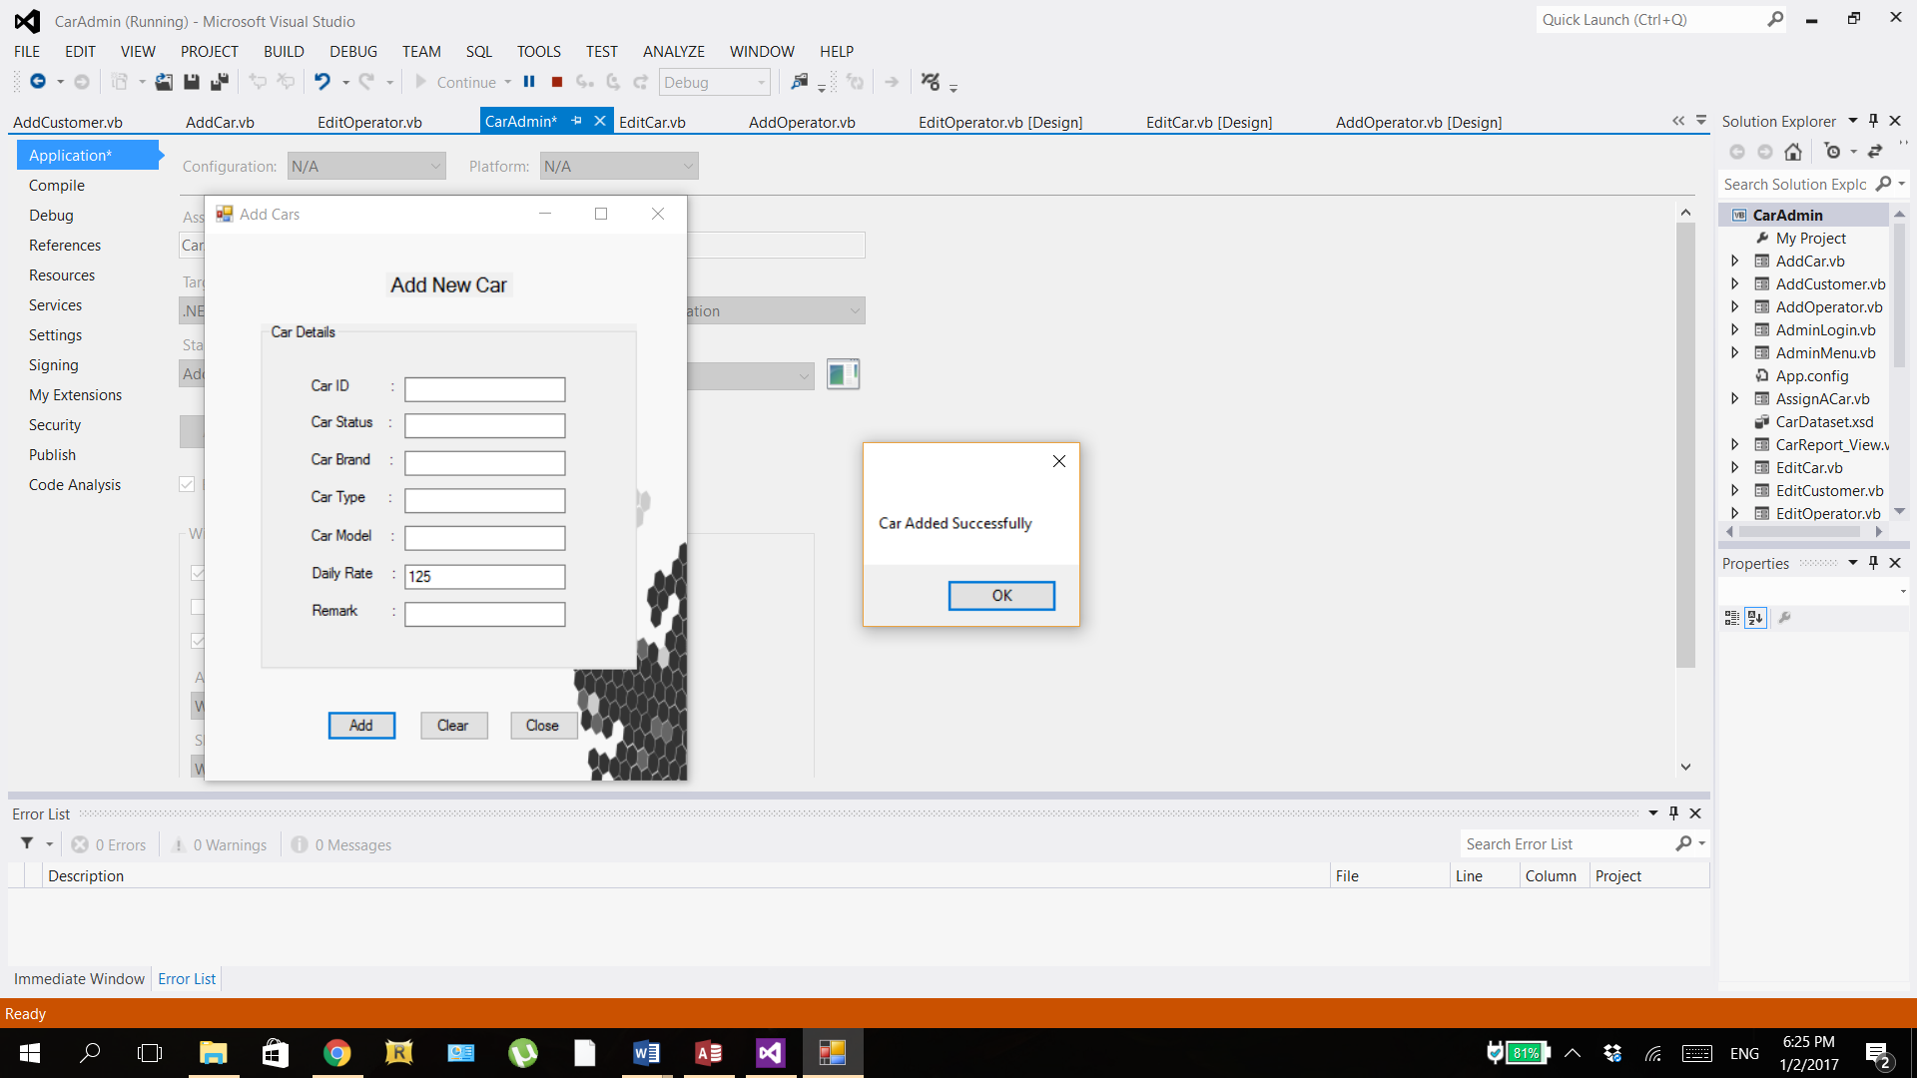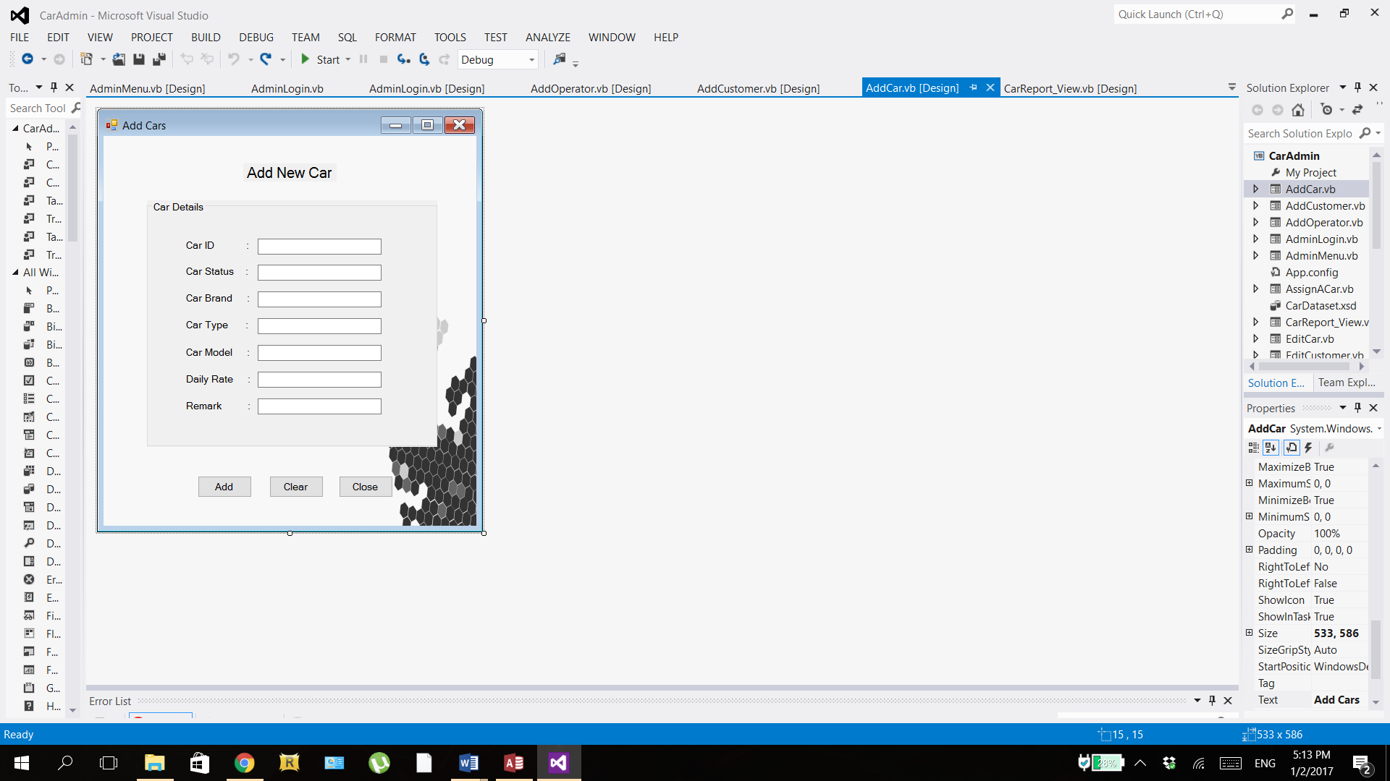

*Figure 1: Message box appears once user clicks ‘Add’ button*

Step 1: Enter data into textboxes

OR

Step 2: Click ‘Add’ button

Step 3: Click ‘Clear’ button

Step 4: Click ‘Close’ button

*Figure 1: Add New Car form*

In Add Car form, user can enter the details of the new car in the textboxes available. The Car ID is the unique plate number of the car; the Car Status can be either ‘Rented’ or ‘Available’; the Car Brand is the company who invented the car such as Proton, Audi, etc,; the Car Type would be the category that the car falls in such as Sedan, SUV, etc.; the Car Model is the name of the car; the Daily Rate is the rental price of the car per day; and Remark is any additional notes which is optional to fill in. After filling in these details, user can click ‘Add’ button to add the car record into the car table in the database. A message box will then appear with “Car Added Successfully” as shown in Figure 2. If user wants to clear all the textboxes, user can click the ‘Clear’ button. If there are no more changes, user may click the ‘Close’ button to exit the form. Like any other forms, user is not allowed to go to other forms until this form is closed.

### 4.2.3 Edit Car Form

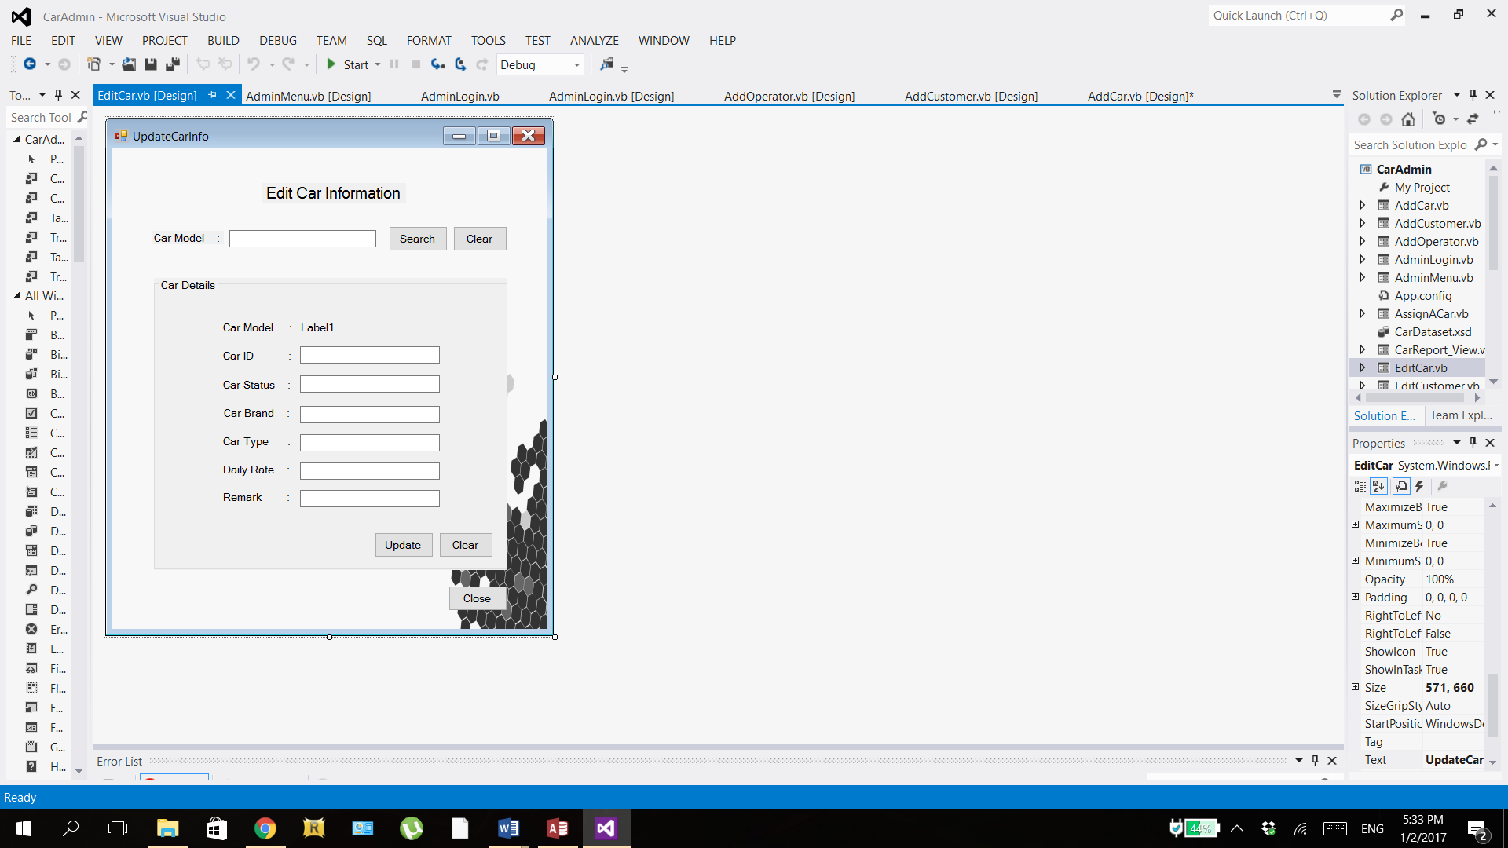

OR

Step 5: Click ‘Update’ button

Step 6: Click ‘Clear’ button

Step 7: Click ‘Close’ button

OR

Step 1: Enter car model in search textbox

Step 2: Click ‘Search’ button

Step 3: Click ‘Clear’ button

Step 4: Edit data in textboxes

This form is used to edit car information in the database. When the form loads, only the search items at the top and close button at the bottom are shown whilst the group box and its items are remained hidden. Firstly, admin has to enter the car model in the search textbox and click the ‘Search’ button or admin can click the ‘Clear’ button next to it to erase the contents of the search textbox. If the record is found, the group box will be made visible containing the car details of the searched car. But if record is not found, a message box will pop up saying “Car Not Found”. After the group box shows up, admin can see the details of the car in the textboxes which can be edited. Admin can edit all car details except Car Model which is in the form of unmodifiable label. Once changes have been made, admin can click the ‘Update’ button to update the car record in database with the new changes. Otherwise, admin can click ‘Clear’ button in the group box to clear all the textboxes. If there are no more changes to be made, admin can click the ‘Close’ button to exit the form.

### 4.2.4 Remove Car Form

Remove Car

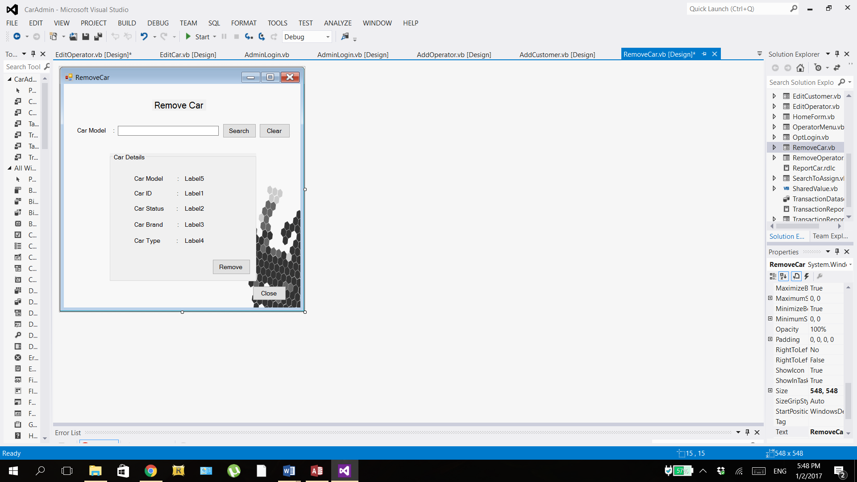

Step 4: Click ‘Remove’ button

Step 5: Click ‘Close’ button

OR

Step 1: Enter operator name in search textbox

Step 2: Click ‘Search’ button

Step 3: Click ‘Clear’ button

This form is used by admin to remove car record from the database. When the form loads, the group box and its items are hidden. User must first enter the car model in the search textbox and click the ‘Search’ button to have the results (car details) retrieved, or else user can click the ‘Clear’ button to clear the search textbox. If the car record is found, the group box will be made visible showing the car details, otherwise a message box will pop up saying “Car Not Found”. In this form, user is not allowed to edit the car details shown in the group box as it is displayed in labels for the sole purpose of clarifying that this is the car that user wants to remove. When user is sure, user can click the ‘Remove’ button to remove the car record from the database. If there are no more cars to be removed, user can click the ‘Close’ button at the button to exit the form.

### 4.2.5 Add Operator

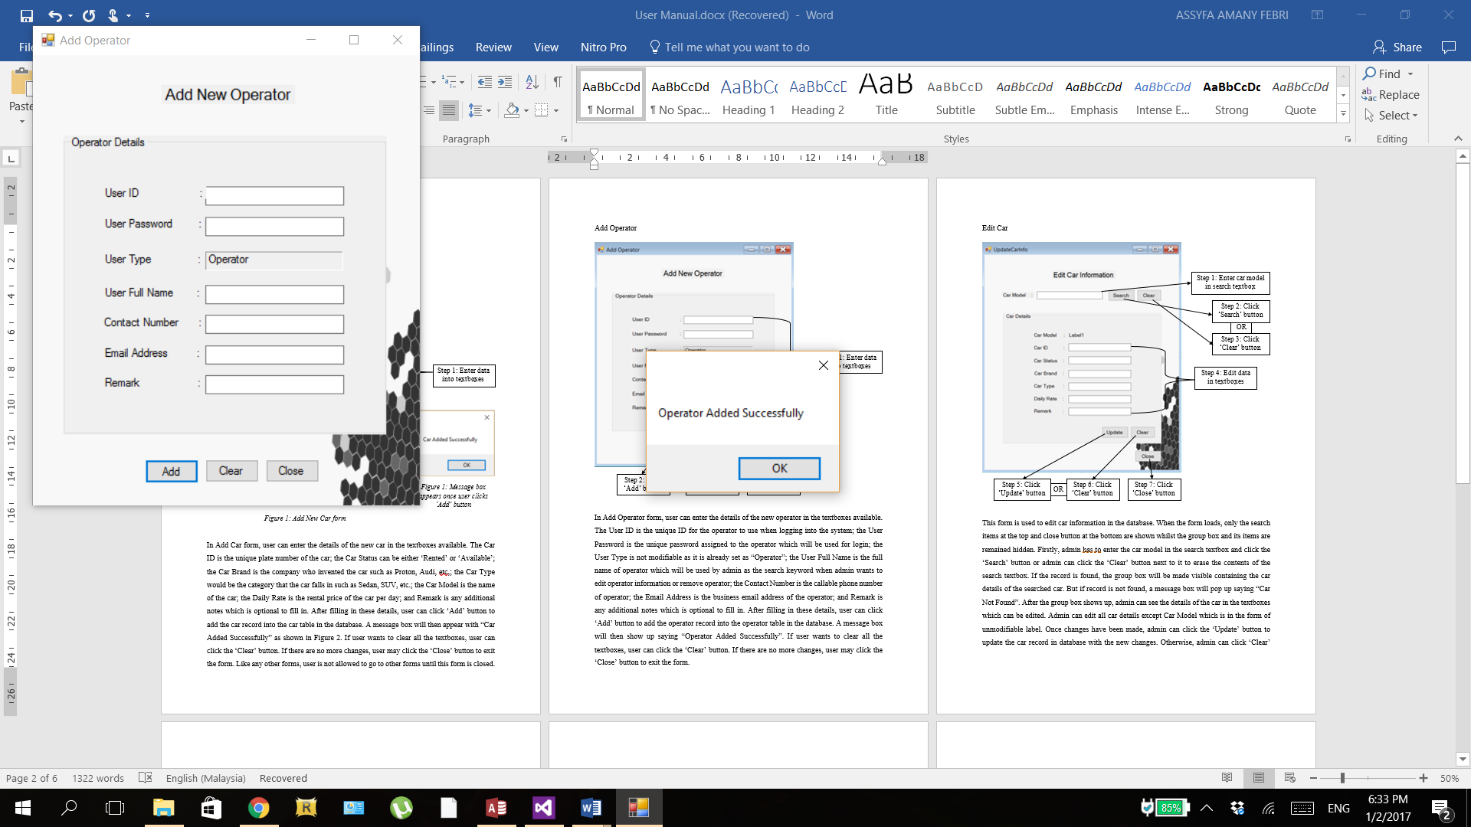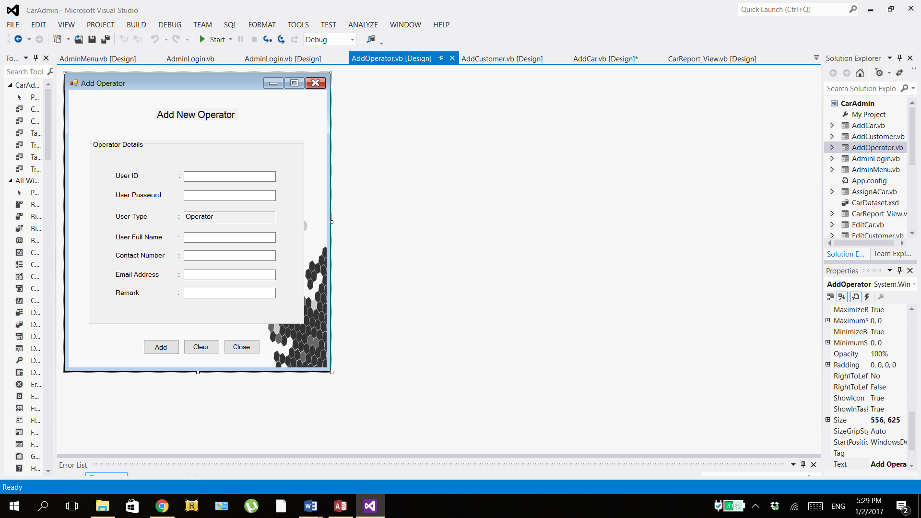

*Figure 1: Message box appears once user clicks ‘Add’ button*

OR

Step 2: Click ‘Add’ button

Step 3: Click ‘Clear’ button

Step 4: Click ‘Close’ button

Step 1: Enter data into textboxes

*Figure 1: Add New Operator form*

In Add Operator form, user can enter the details of the new operator in the textboxes available. The User ID is the unique ID for the operator to use when logging into the system; the User Password is the unique password assigned to the operator which will be used for login; the User Type is not modifiable as it is already set as “Operator”; the User Full Name is the full name of operator which will be used by admin as the search keyword when admin wants to edit operator information or remove operator; the Contact Number is the callable phone number of operator; the Email Address is the business email address of the operator; and Remark is any additional notes which is optional to fill in. After filling in these details, user can click ‘Add’ button to add the operator record into the operator table in the database. A message box will then show up saying “Operator Added Successfully”. If user wants to clear all the textboxes, user can click the ‘Clear’ button. If there are no more changes, user may click the ‘Close’ button to exit the form.

### 4.2.6 Edit Operator Form

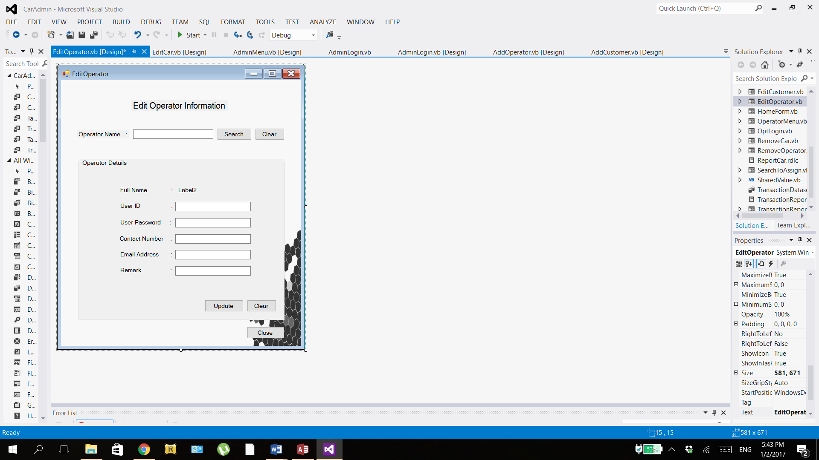

OR

Step 1: Enter operator name in search textbox

Step 2: Click ‘Search’ button

Step 3: Click ‘Clear’ button

Step 4: Edit data in textboxes

OR

Step 5: Click ‘Update’ button

Step 6: Click ‘Clear’ button

Step 7: Click ‘Close’ button

This form is used to operator car information in the database and the procedure is the same as Edit Car form. When the form loads, the group box and its items are remained hidden. Firstly, admin has to enter the operator full name in the search textbox and click the ‘Search’ button or admin can click the ‘Clear’ button next to it to erase the contents of the search textbox. If the record is found, the group box will be made visible containing the operator details of the searched operator, or else a message box will pop up saying “Operator Not Found”. After the group box shows up, admin can see the details of the operator in the textboxes which can be edited. Admin can edit all operator details except Full Name which is in the form of unmodifiable label. Once changes have been made, admin can click the ‘Update’ button to update the operator record in database with the new changes. Otherwise, admin can click ‘Clear’ button in the group box to clear all the textboxes or click the ‘Close’ button to exit the form.

### 4.2.7 Remove Operator Form

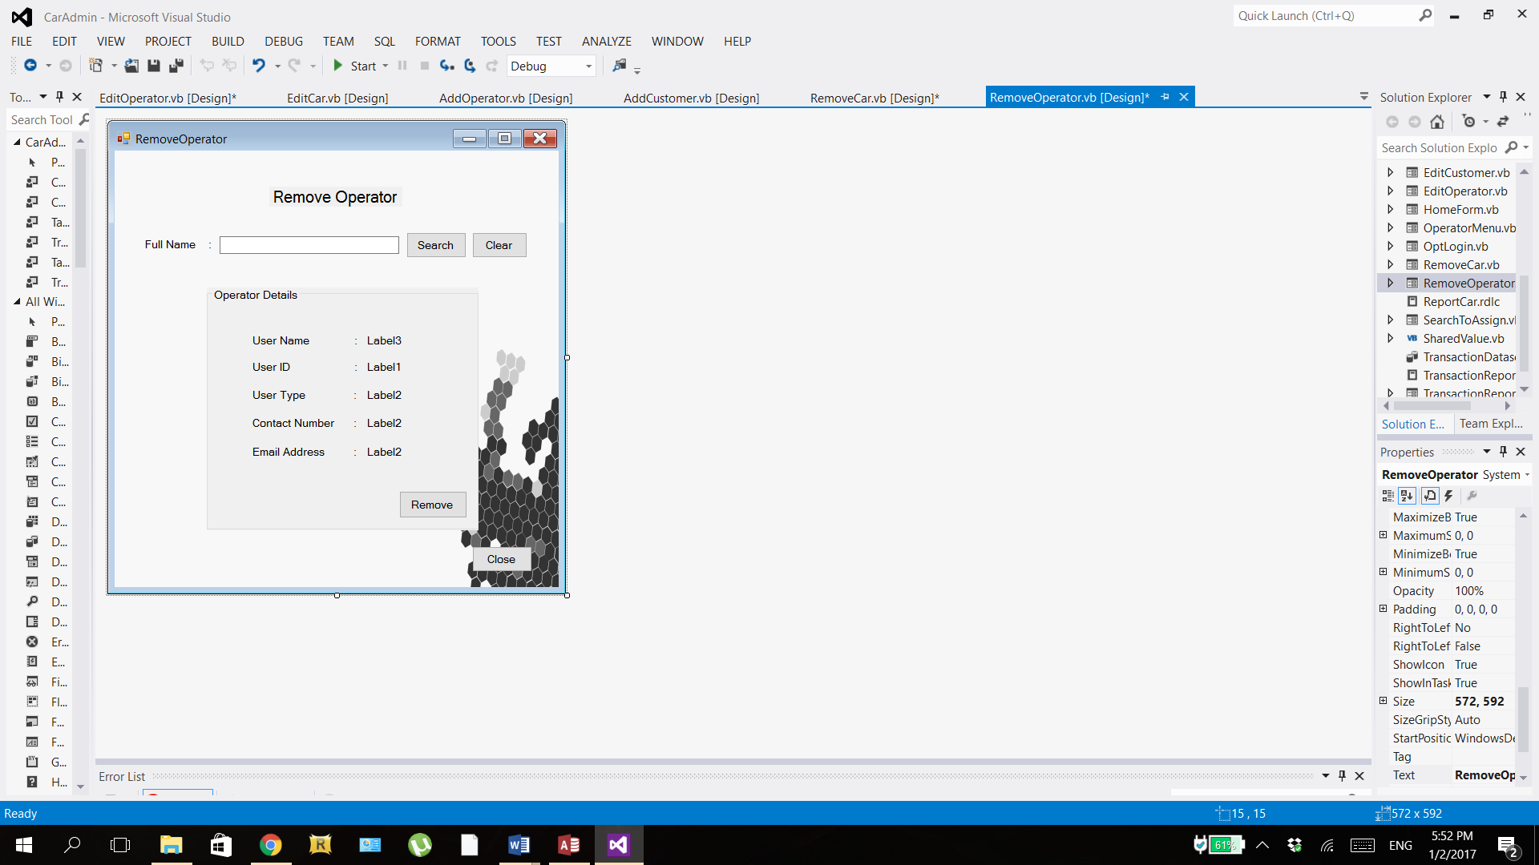

Step 4: Click ‘Remove’ button

Step 5: Click ‘Close’ button

OR

Step 1: Enter operator name in search textbox

Step 2: Click ‘Search’ button

Step 3: Click ‘Clear’ button

This form is used by admin to remove operator record from the database and the procedure is the same as Remove Car form. When the form loads, the group box and its items are hidden. User must first enter the operator name in the search textbox and click the ‘Search’ button to have the results (operator details) retrieved, or else user can click the ‘Clear’ button to clear the search textbox. If the operator record is found, the group box will be made visible showing the operator details, otherwise a message box will pop up saying “Operator Not Found”. In this form, user can only view not edit the details as they are displayed in labels for the sole purpose of clarifying that this is the operator that user wants to remove. When user is sure, user can click the ‘Remove’ button to remove the operator record from the database. If there are no more operator to be removed, user can click the ‘Close’ button at the button to exit the form.

## 4.3 Operator Interface

### 4.3.1 Operator Menu Form

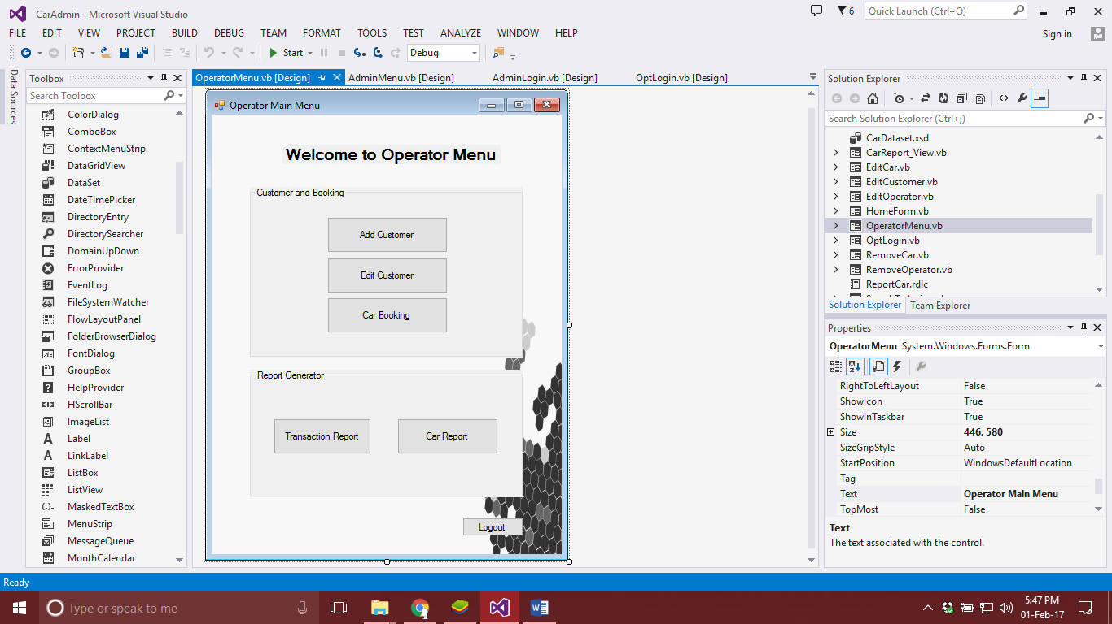

Step 1: Choose Add, Edit Customer, or Car Booking

Step 3: Logout

Step 2: Choose which report to generate

This form is displayed once the user logs in as operator successfully. This is the menu form of operator, it consists of buttons that lead to different task that an operator can perform such as Adding and Editing the customer information or car booking. Apart from that there are two types of report button Transaction report and Car report provided for operator which the operator can click to view the detailed report. At the bottom right corner is the logout button provided for operator if the operator wishes to log out of the system, he/she can simply click on the button to do so.

### 4.3.2 Add Customer Form

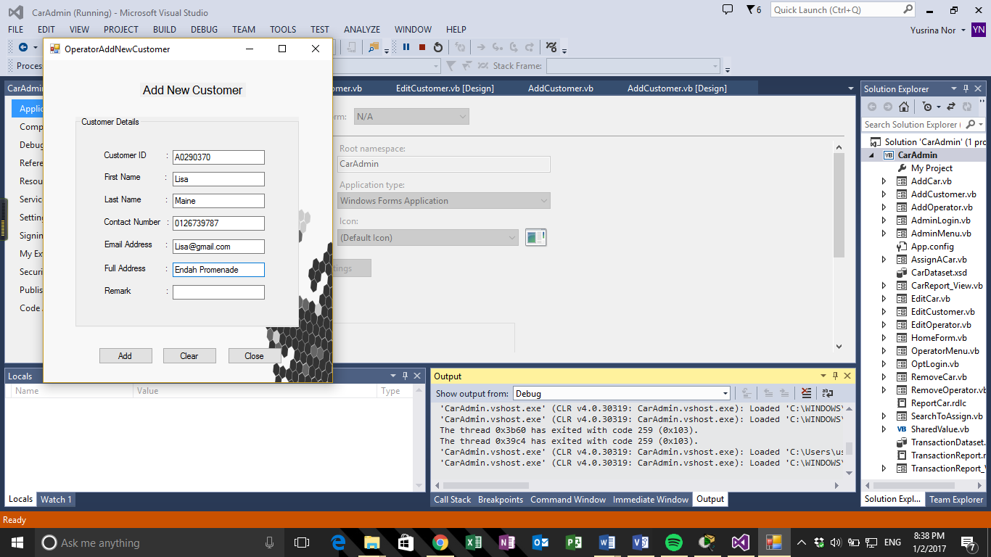

OR

Step 1: Enter data into fields

Step 2: Click ‘Add’ button

Step 3: Click ‘Clear’ button

Step 4: Click ‘Close’ button

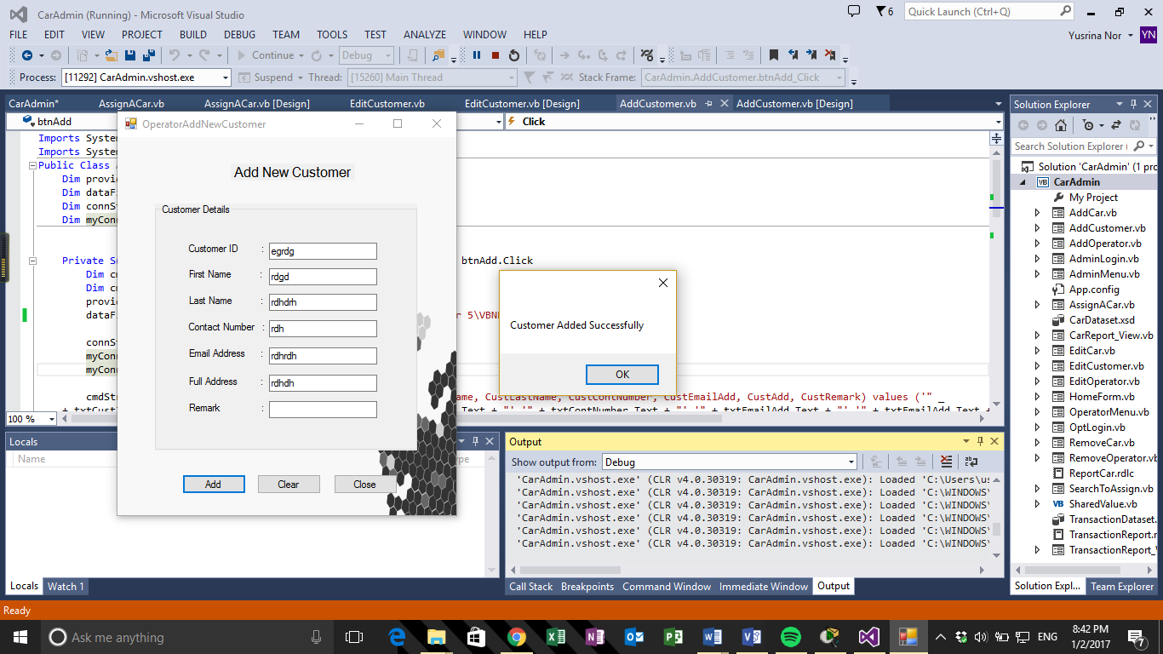

This form allows the operator to ass customers into the system if there are any new walk-in customers wanting to rent a car. To add a new customer, the operator must first enter the customer’s details into the fields provided. The fields consists of customer ID, first name, last name and contact number, e-mail address, full address and remarks (optional). Once the details have been entered, the user could proceed by clicking the ‘Add’ button. If the ‘Add’ button has been clicked, a message box will appear with a message, “Customer Added Successfully”, verifying that the customer has been stored in the database.

Otherwise, if the user wants to reset the whole fields that have been filled, the ‘Clear’ button could be clicked. Once process of adding a new customer is done, the user could close the form by clicking the ‘Close’ button.

### 4.3.3 Edit Customer Form

Step 1: Enter name into search field/textbox

Step 2: Click ‘Search’ button

Step 3: Click ‘Clear’ button

OR

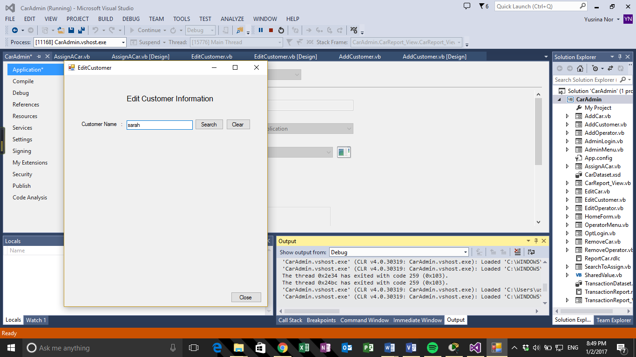

Step 4: Enter changes to data

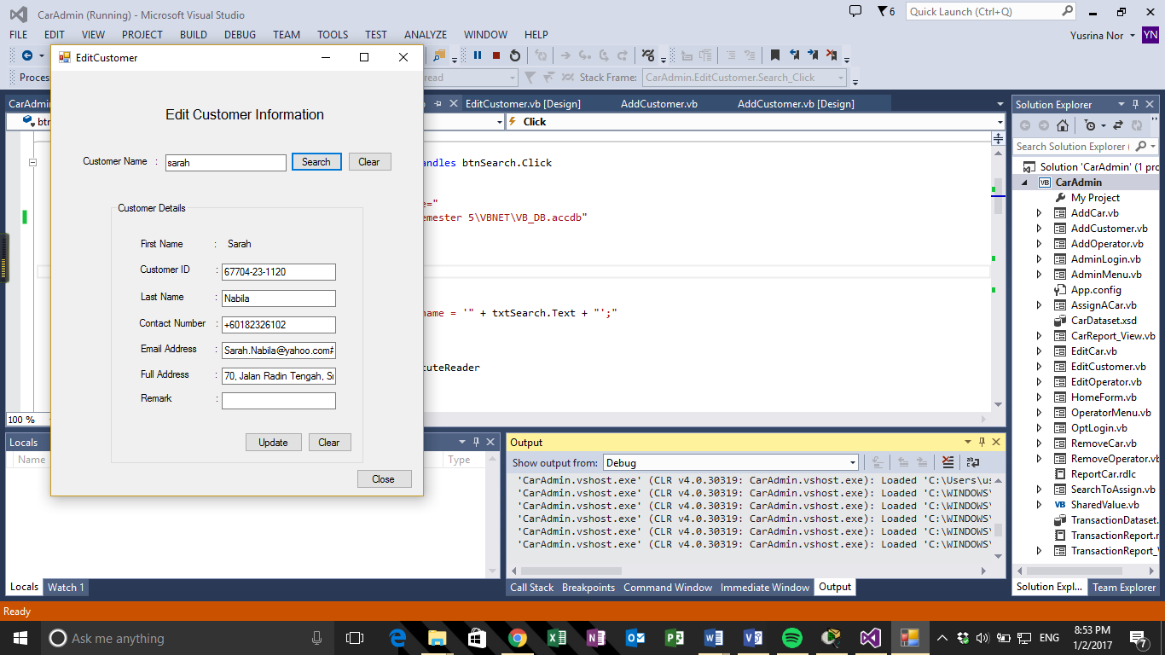

OR

Step 6: Click ‘Clear’ button

Step 5: Click ‘Update’ button

Step 7: Click ‘Close’ button

Step 4: Enter data to make changes

This form allows the operator to update existing customer’s information if there request any changes. In order to update the information, the user must search for the customer’s data by entering their name into the search field/box. Once their name has been entered, the user can proceed to click the ‘Search’ button or if there are any changes or errors entered in the search field, the ‘Clear’ button can be clicked.

Once the user has proceeded with the search process, the customer’s details would appear, where it will display the first name, customer ID, last name, contact number, e-mail address, full address and remarks. However, the first name is not editable and the user can only make changes to the rest of the fields. Once changes have been made, the user can proceed by clicking the ‘Update’ button or if there is a need to clear the fields, the ‘Clear’ button can be clicked. Once all changes have been made, the user can close the form by clicking the ‘Close’ button.

### 4.3.4 Search to Assign Form

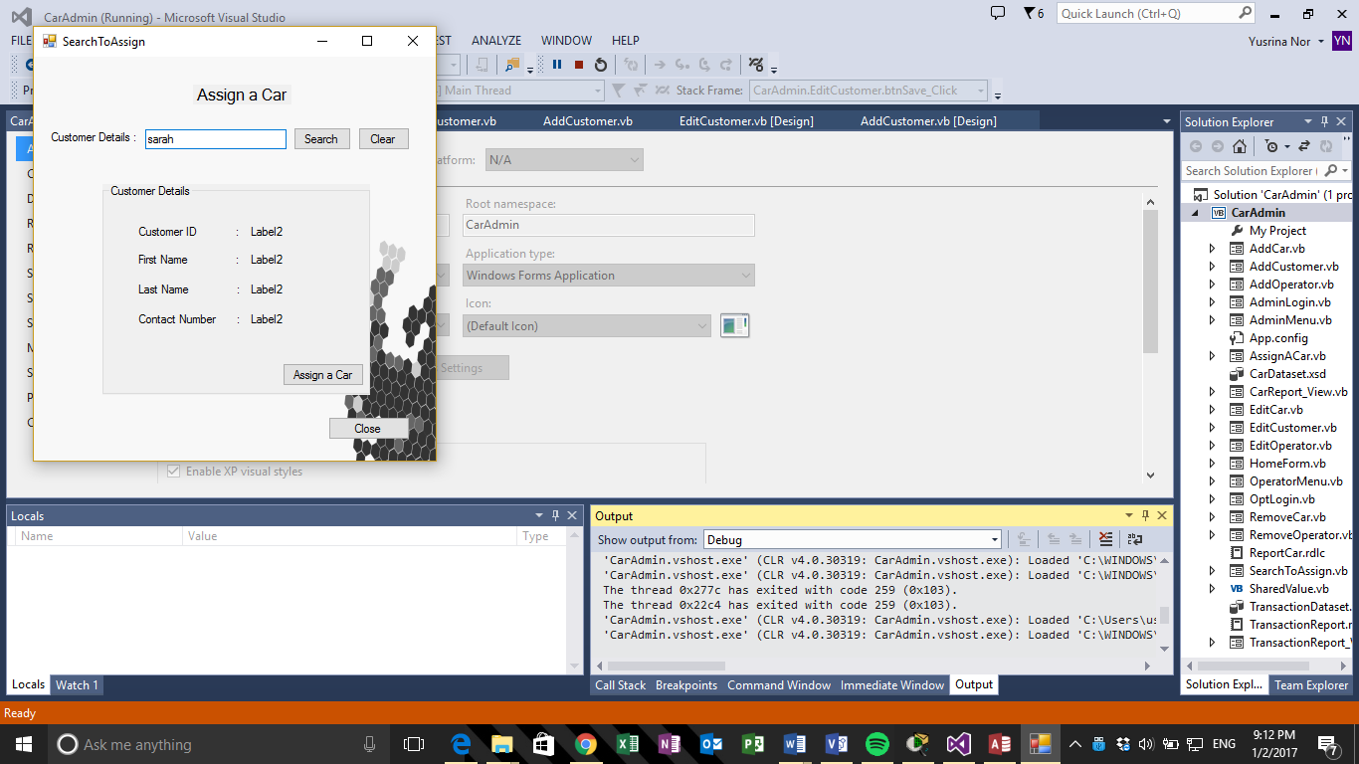

Step 1: Enter name into search field/textbox

Step 2: Click ‘Search’ button

OR

Step 3: Click ‘Clear’ button

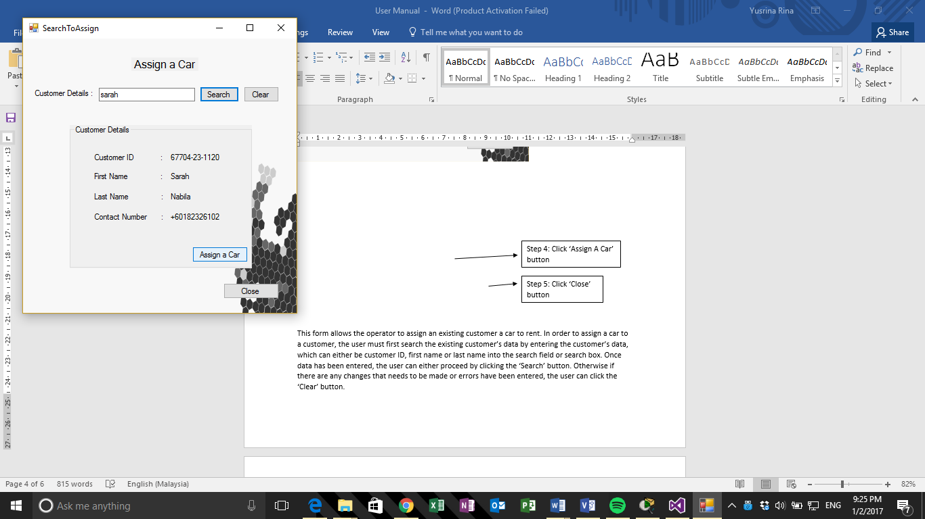

Step 4: Click ‘Assign A Car’ button

Step 5: Click ‘Close’ button

This form allows the operator to assign an existing customer a car to rent. In order to assign a car to a customer, the user must first search the existing customer’s data by entering the customer’s data, which can either be customer ID, first name or last name into the search field or search box. Once data has been entered, the user can either proceed by clicking the ‘Search’ button. Otherwise if there are any changes that needs to be made or errors have been entered, the user can click the ‘Clear’ button.

Once the search process is done, the customer’s details would appear and it would display the customer ID, first name, last name and contact number. The details are not editable as it is for viewing only. Once the customer’s details are confirmed, the user would proceed by clicking the ‘Assign A Car’ button, which would redirect the user to another form. Otherwise, the user would click the ‘Close’ button.

### 4.3.5 Assign a Car Form

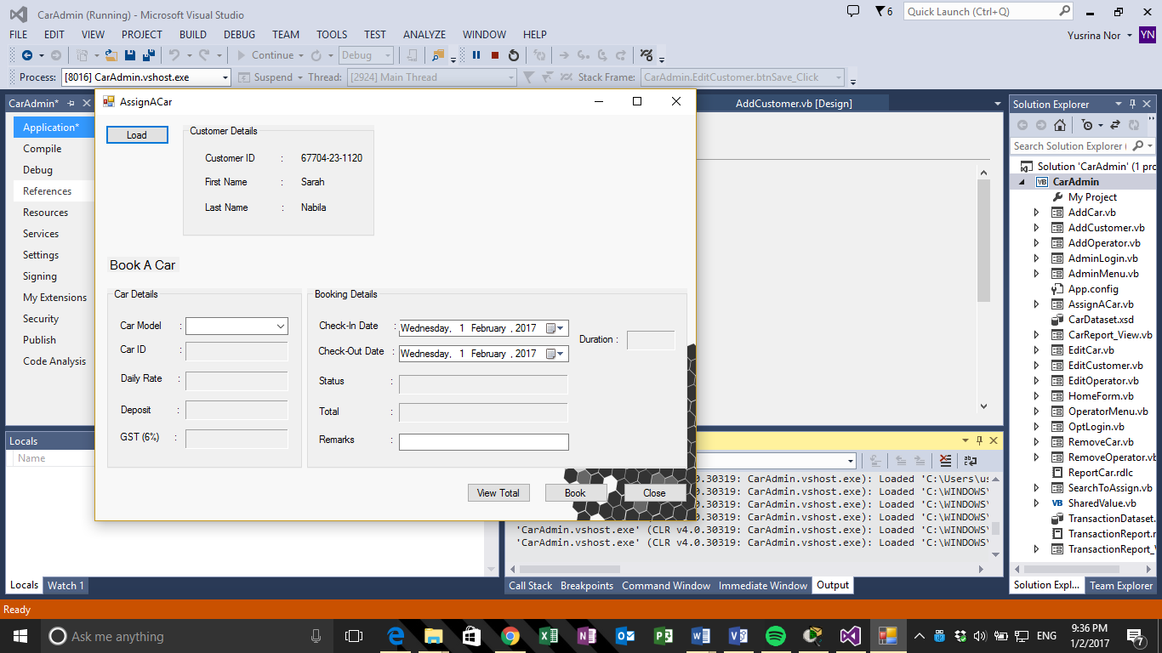

Step 1: Click ‘Load’ button

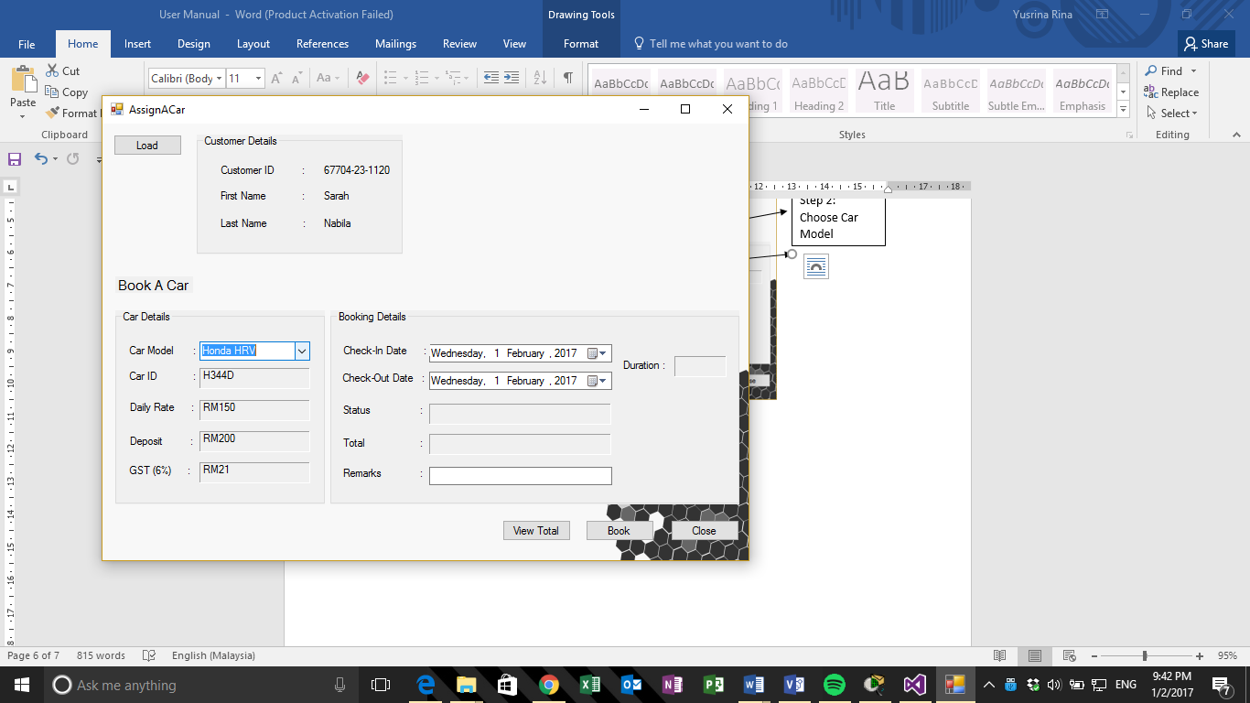

Step 2: Select Car Model

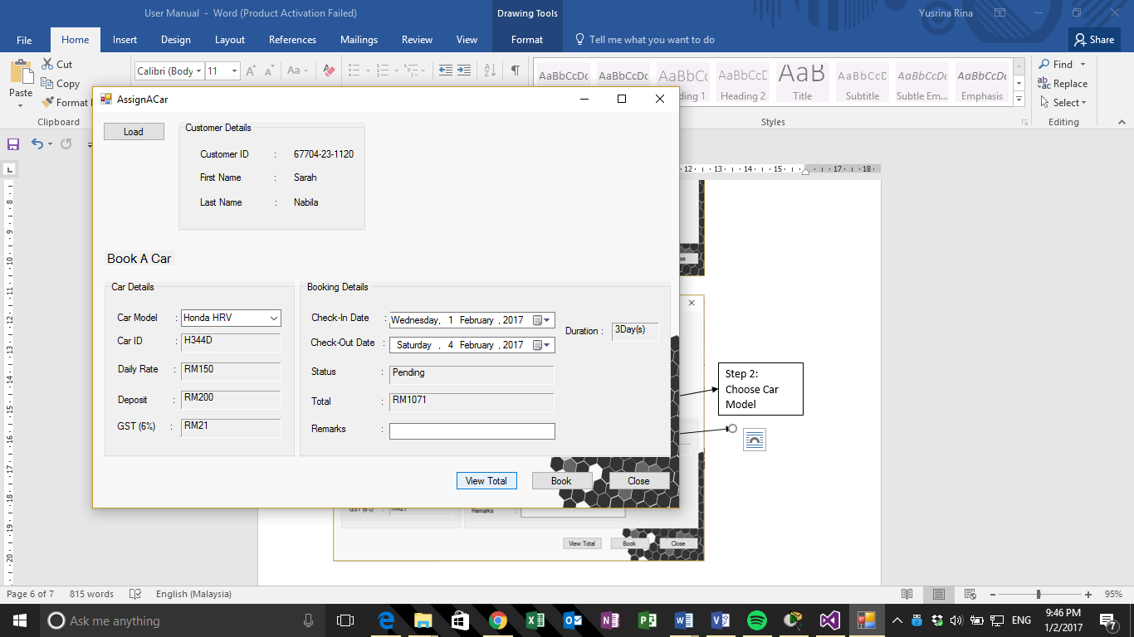

Step 3: Select check-in and check-out date

Step 4: Click ‘View Total’ button

Step 5: Enter additional information (optional)

Step 6: Click ‘Book’ button

Step 7: Click ‘Close’ button

This form allows the operator to perform bookings for the customers wanting to rent a car. In order to perform booking, the user must click the ‘Load’ button is order to display the customer’s details which have been searched in the previous form. One the details have been displayed, the user must choose the car model according to the customer’s preferences from the dropdown list. Once the car model has been chosen, the car’s details consisting of the car ID, daily rate, deposit and the tax amount.

The user would then proceed to the booking details, in which the check-in date and check-out date would be selected according to customer’s preferences. The ‘View Total’ can then be clicked which will display the duration of the particular car being rented, along with the status and total amount to be paid. The user would also enter any additional information provided by the customer in the remarks field if necessary.

Once the booking details have been filled in, the user would then click the ‘Book’ button in which the transaction information would then be stored in the transaction table in the database, and a message box would show with a message, “Transaction Record Has Been Saved Successfully”.

### 4.3.6 Car Report Form



Close after viewing

Car report form is displayed after the operator clicks on the car report button on the menu to generate this report. This report is also linked with the database but consists of information related to the car rather than transaction. It shows the car type, model and the status of the car whether it is available or not. Apart from that at the bottom right corner there is a button provided for the operator to close the report if he/she wishes to.

### 4.3.7 Transaction Report

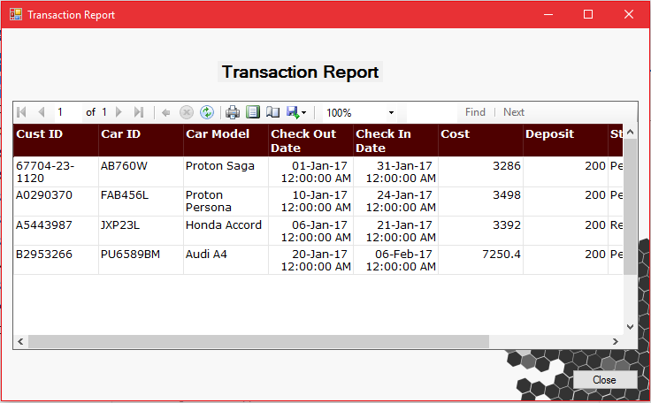

Close after viewing

If the operator clicks on the Transaction report button provided in the menu, that button directs the operator to this form. This form is linked from database of the system that shows the information about the transactions made, displaying information such as the check in and out date of the customer renting a car, the cost and deposit the customer made etc. At the bottom right corner there is a button provided for the operator to close the report if he/she wishes to.